# Cockpit Assembly

The assembly of the cockpit is done in several sub assemblies and is pieced together throughout the build process.

## SubAssy Cockpit Bottom and Front

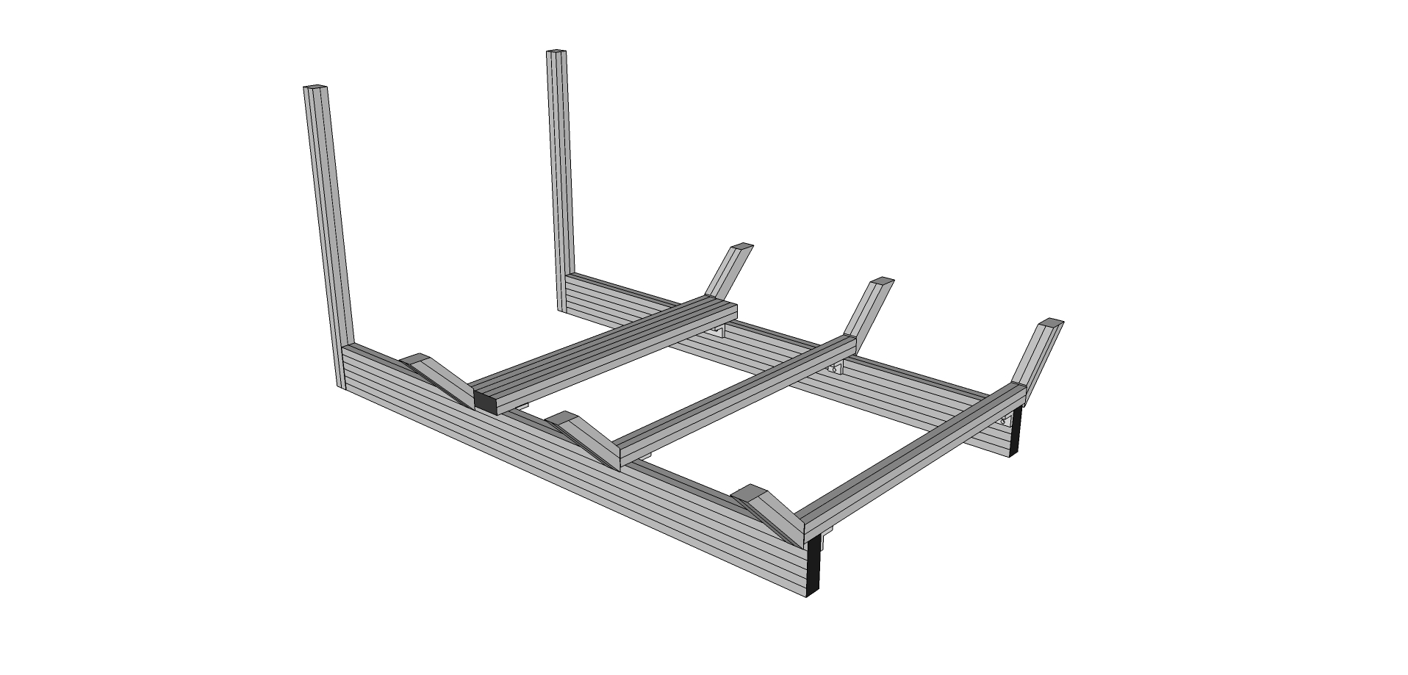

Step #1 Prep Two Bottom Rails Frame (9230301) with 6 End Fastener Assemblies (9233381). Orient the Two Bottom Rails approximately 16” apart on their 1” sides. It is important to make sure the single tapped hole end is the top hole for Step #7 correct positioning.

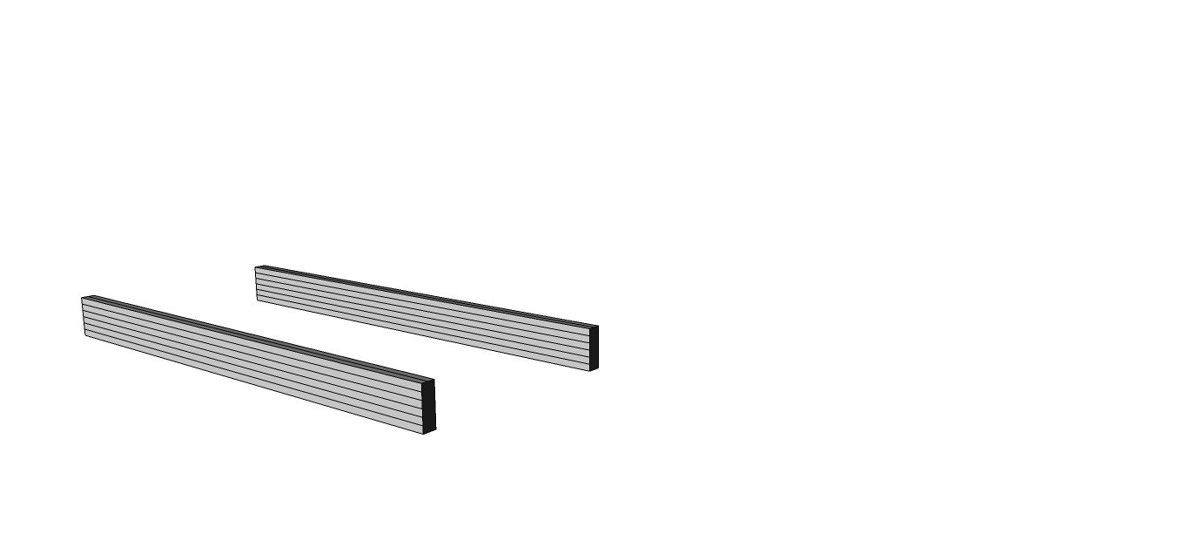

Step #2 With the End Fasteners (9233381) slightly loosened, slide the (Front Vertical) 9230303 into place over the End Fasteners flush to the bottom of rail. When aligned, the access hole on the mating profile should align with the BHSCS. To tighten the connection, place a T-handle hex wrench into access hole until the wrench head inserts into the BHSCS. Tighten all three clockwise until secure forming a 90 degree angle between Bottom Rails 9230301 and Front Verticals (9230303).

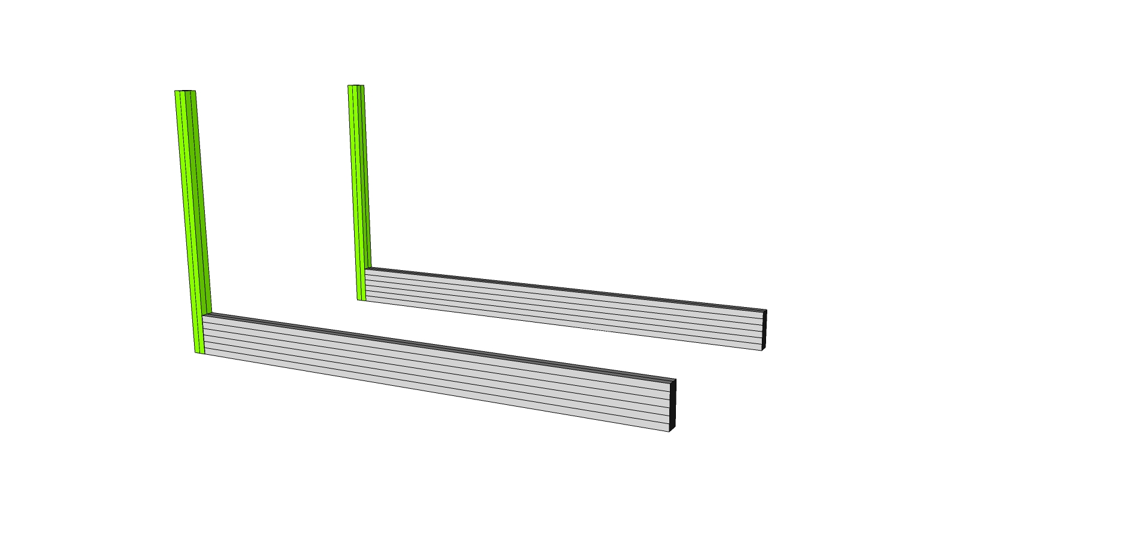

Prep Two Front Verticals (9230303) with the *bolts* of 2 End Fastener Assemblies (9233381) on the top holes. **IMPORTANT: Use only the 9233065 bolt without the Wing Clip.**

Step #3 - Prep four 2 hole inside corner bracket connectors (9234119) with 8 of the Econ T-Nuts and Bolts 9233393 and two 6 hole inside corner brackets (9234015) with 12 of the Econ T-Nuts and Bolts 9233393. Keep the nuts loose to allow sliding into place.

Slide 1 six-hole, then 2 two-hole brackets (9234119) into the top inside channel of each of the Bottom Rails (9230301). Tighten Brackets at 25”, 12 1/2” and 1/2” on center from back of Bottom Rail.

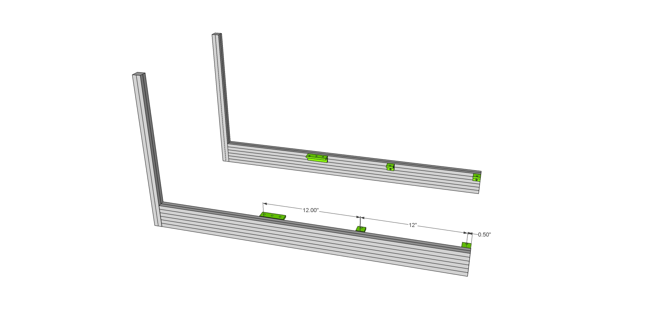

Step #4 With the Econ T-nuts slightly loosened, slide all three (Front, Center, Back) Main Lower Cross Members (9230309 & 9230309F) as shown. Tighten Brackets on Cross Members leaving 3” hanging out on each over the Bottom Rail.

**IMPORTANT: Slide 4 T-Nuts into the top channels of both the rear and the middle cross members. These will be used for seat mounting later and will be trapped inside the channel on the next step. Slide 4 in each if using the normal seat configuration or 2 in each if using the wide seat configuration. Consult the Seat Mounting SubAssy instructions later in this section to determine which seat mounting configuration is right for your seat.**

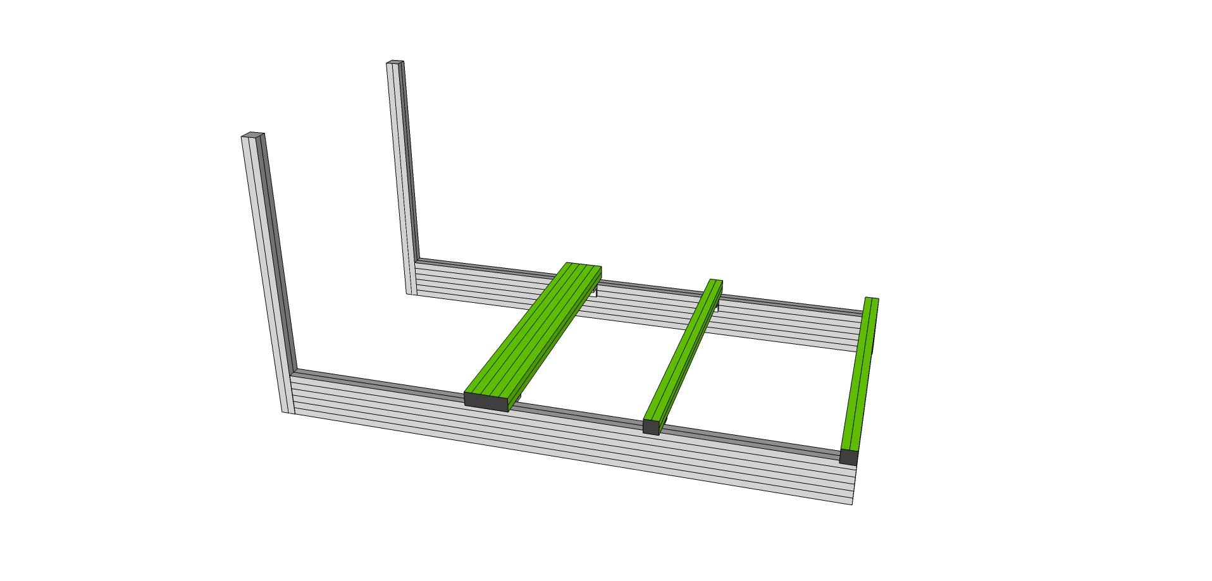

Step #5 Remove Econ T-nut (but leaving the bolt and washer) on six 6” 45 degree supports (9232565) and attach to the Cross Members as shown.

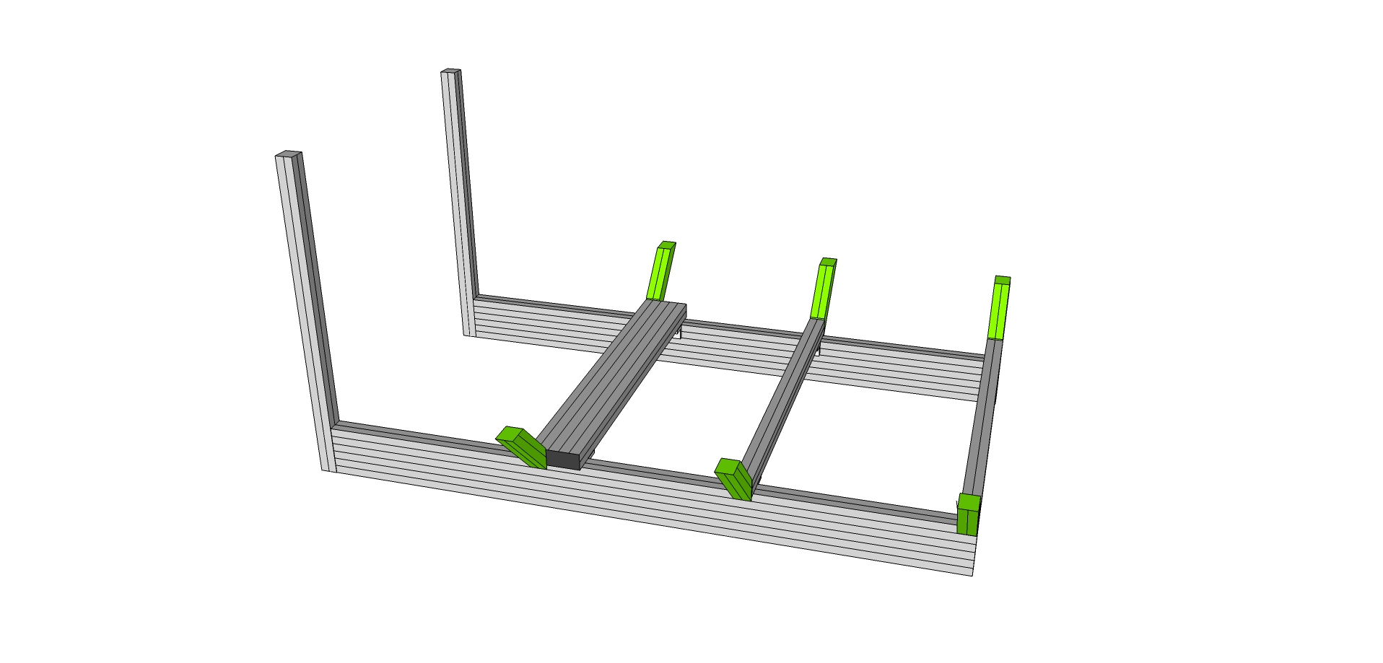

## SubAssy Cockpit Rear

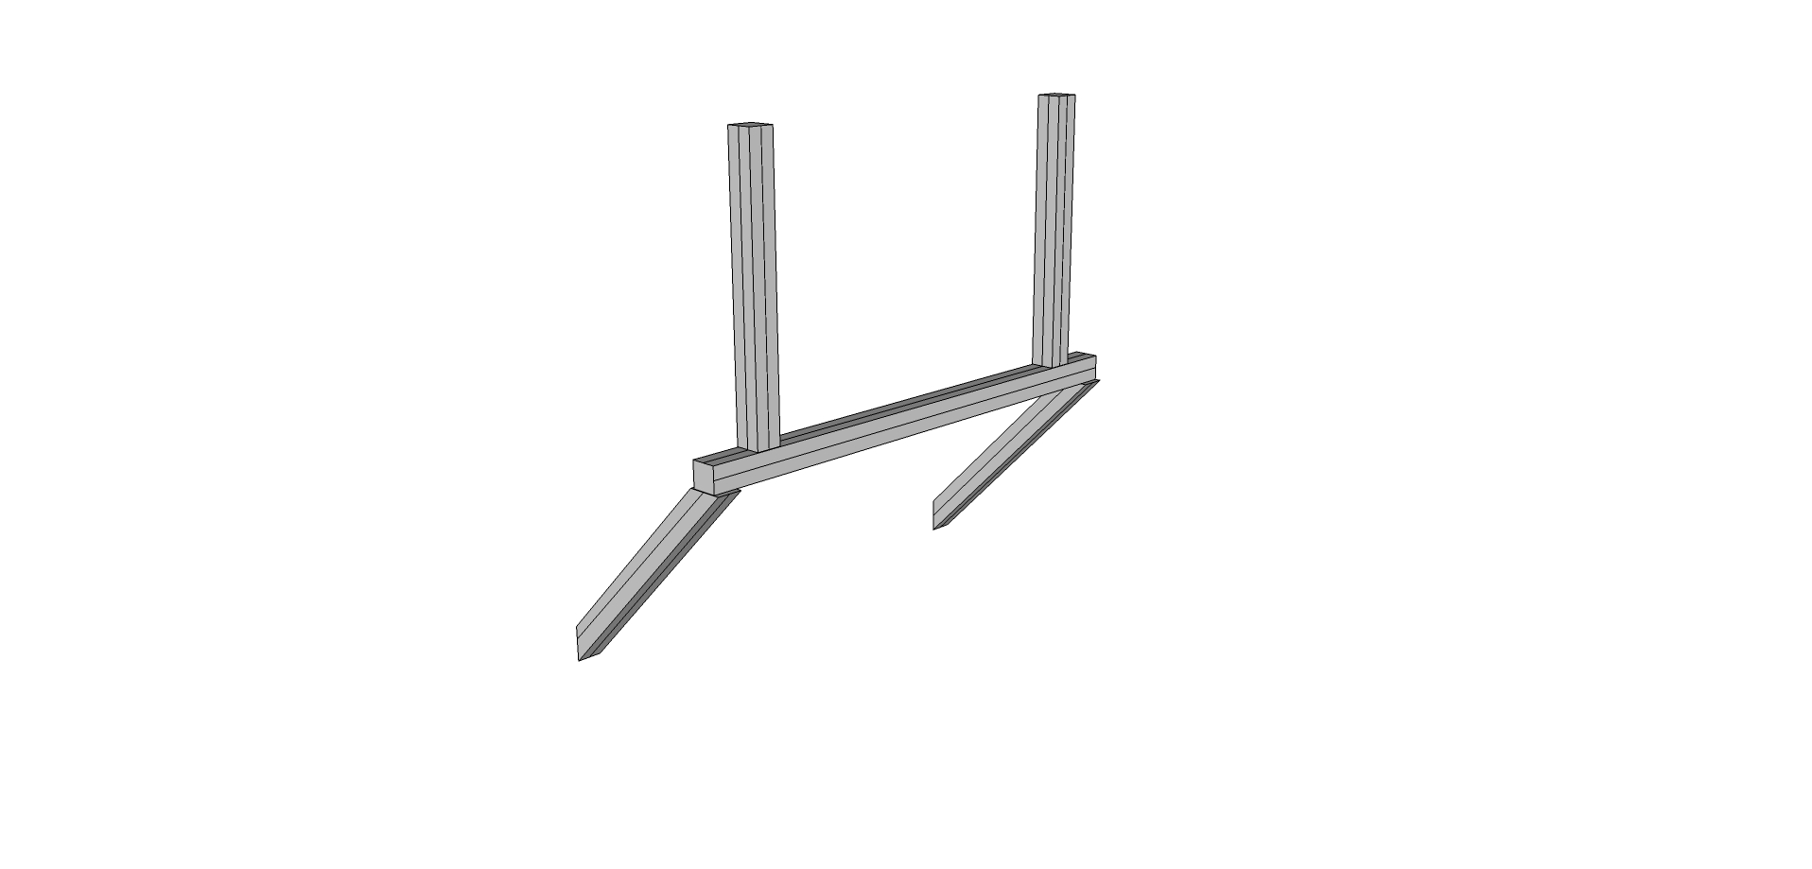

Step #1 Loosen T-nuts on two 12” 45 degree supports 9232570.and slide into the bottom slot of the Bottom Rear Horizontal Cross Member (9230332).and attach as shown. Tighten Slightly.

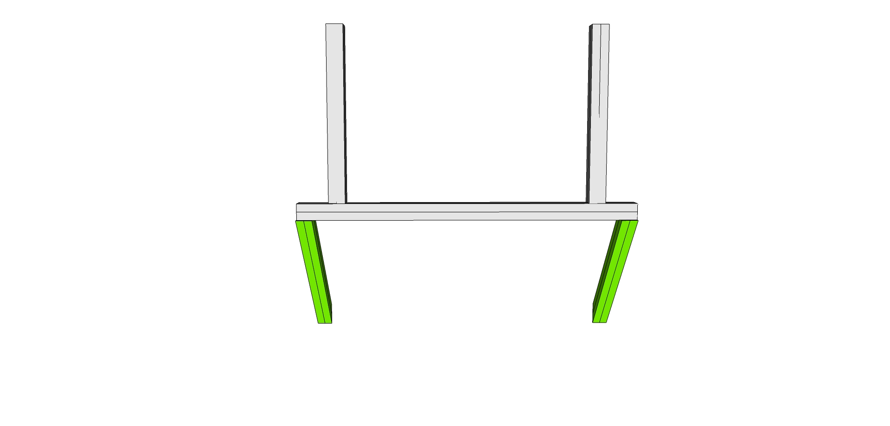

Step #2 Prep Slide three (loose) end fasteners (9233381) in the “top” channel (For the pitch actuator frame) and then with end fasteners (9233381) on the ends, bolt into each pre tapped Rear Vertical (9230310) in place as shown. Tighten.

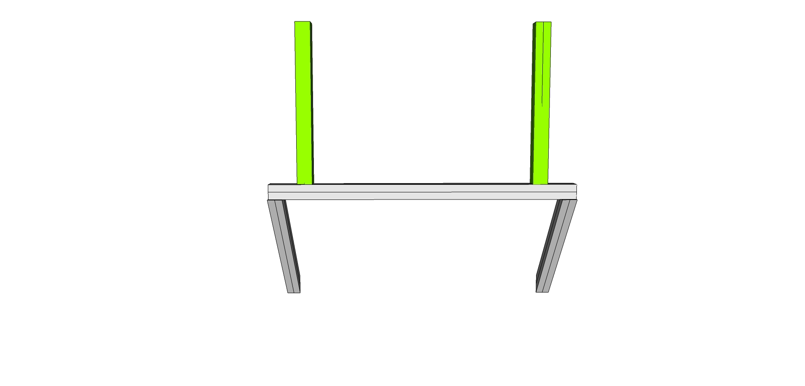

Step #3 Prep Two Rear Verticals (9230310) with the *bolts* of 2 End Fastener Assemblies (9233381) on the top holes. **IMPORTANT: Use only the 9233065 bolt without the Wing Clip.**

## 

## Attach SubAssy Bottom and Front to the Rear

Remove the T-Nuts and bolt the lower half of the rear subassy into each pre tapped top hole of the Bottom Rail (9230301) and attach as shown. Tighten.

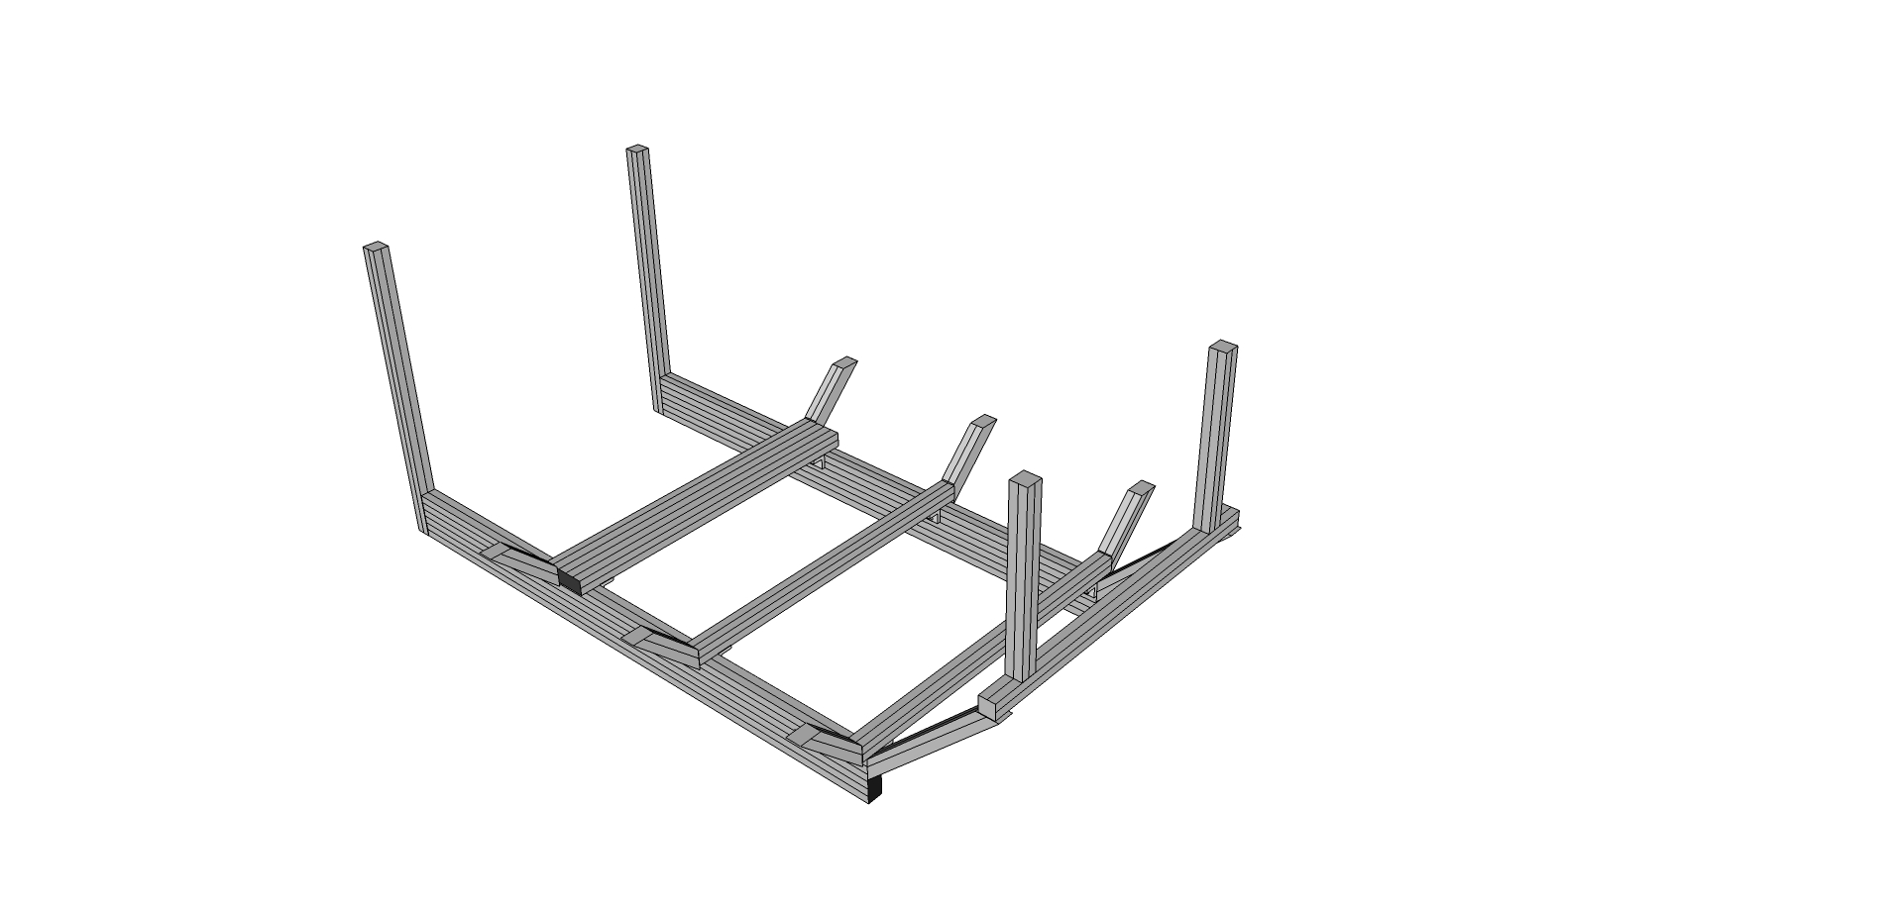

## 

## SubAssy Cockpit Sides – BUILD 2

Step #1 Take four 6” 45 degree supports (9232565) and slide one of the loosened ends onto each one of four Lower Sides (9230314 and 9230314B)

Step #2 Prep all four of the lower sides (9230314 and 9230314B) with End Fasteners (six 9233381 fasteners in total).

Step #3 Slide the pre tapped ends of four of the Main Verticals (9230313) through the loosened 6” 45 degree supports (923265) and into the end fastener of the Lower Sides (9230314 and 9230314B) forming a 90 degree angle as shown. Two of the assemblies will use the 9230314 lower side with counterbores, the other two will use the standard 9230314 part without the counterbores for the anchor fasteners. (The channels with the counterbores for the anchor fasteners should be oriented toward the front and back, and not outside/inside.) Tighten the end fasteners. You should have four assemblies that look like:

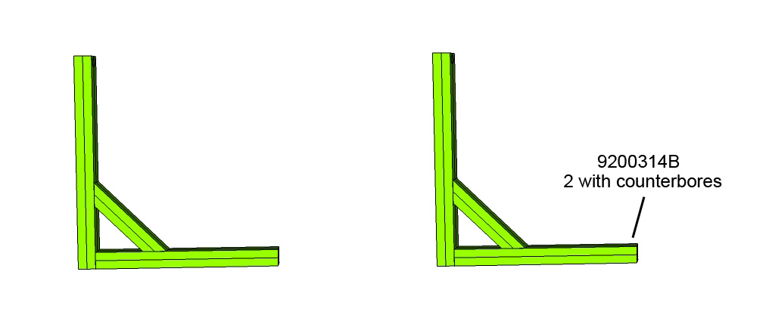

Step #4 Take the two remaining main verticals (9230313) and attach two 12” 45 degree supports (9232570) as shown. Make sure the access hole is on the bottom and the anchor fastener end is at the top. (The channels with the counterbores for the anchor fasteners should be oriented toward the front and back, and not outside/inside.)

Step #5 You should have two assemblies that look like:



Step #6 Take one of the four assemblies from the previous steps and one of the assemblies from the last step, attach using the end fastener in the lower side, through the main vertical as shown

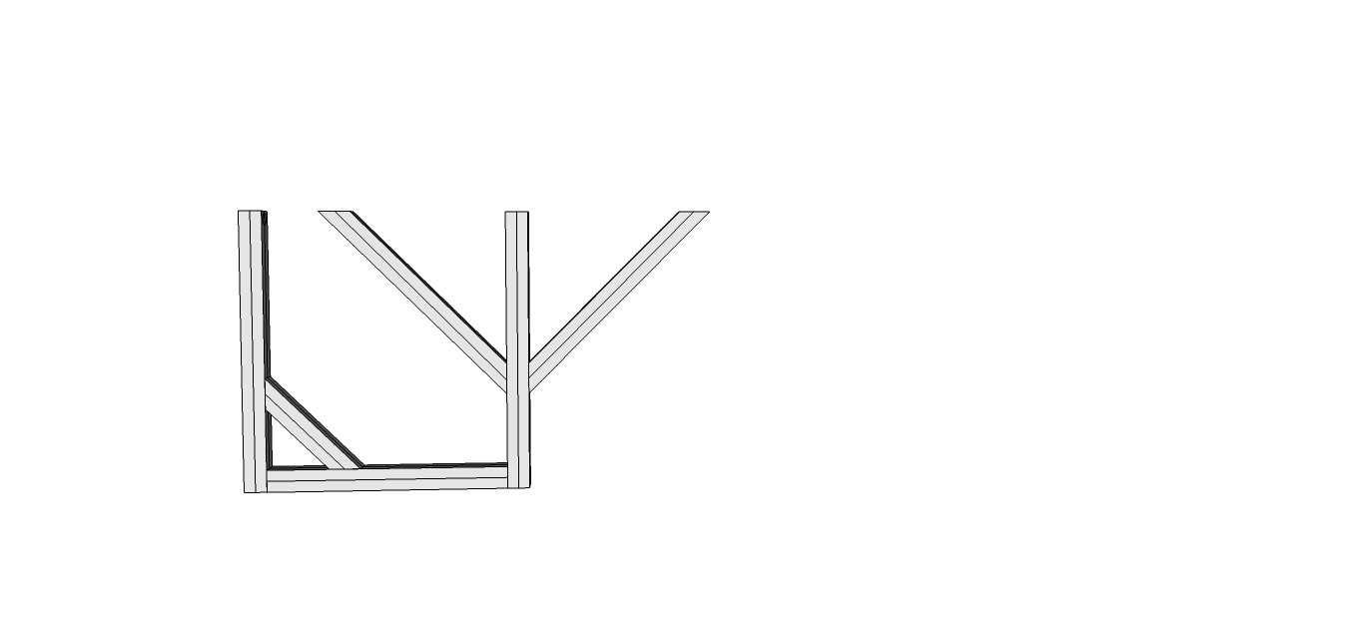

Step #7 Then, attach another one of the four assemblies and fasten to the other side as shown using two anchor fasteners (9233395) in each.

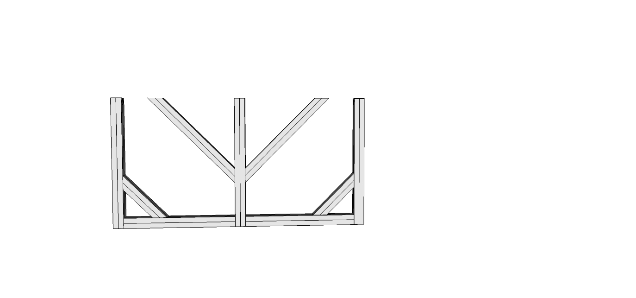

Step #8 Repeat with the other assemblies to end up with two sides that look like the assembly in the previous pic, then attach the sides to the cockpit assembly using the 6 bolts from the 6” 45 degree supports (9232570), bolted into the tapped ends of the main verticals (9230313) as shown.

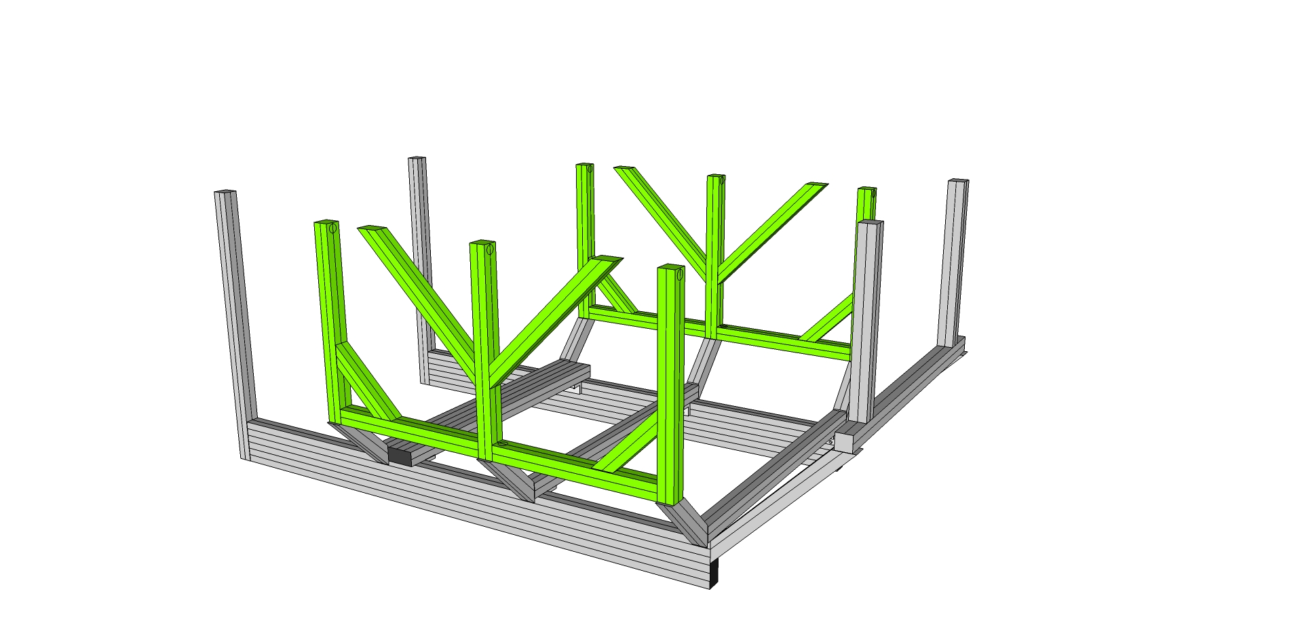

## Connect Top frames to rest of the cockpit Assembly

Step #1 Prep twelve anchor fasteners (9233395) for the top of each Main Verticals (9230313). Anchor Fasteners are composed of three parts: The Head Cap, Screw, the Anchor Cam, and the T-nut. Your Anchor Fasteners should ship Pre-assembled. If assembly is needed, refer to the photo (Note: offset tapped hole in T-nut)

Step #2 Load the assembled anchor fastener into the counterbore hole of all six main verticals (9230313), two in each. Be sure to position the T-nut with the offset hole oriented toward the top of the fastener.

Step #3 While holding the Anchor Fastener in the counterbore hole, slide the Main Upper Side (9230318) over each and over each Econ T-nut from the 12” 45 degree supports (9232570) in place ending ~ 1.25” past flush with rear main vertical. Leave slightly loose until later.

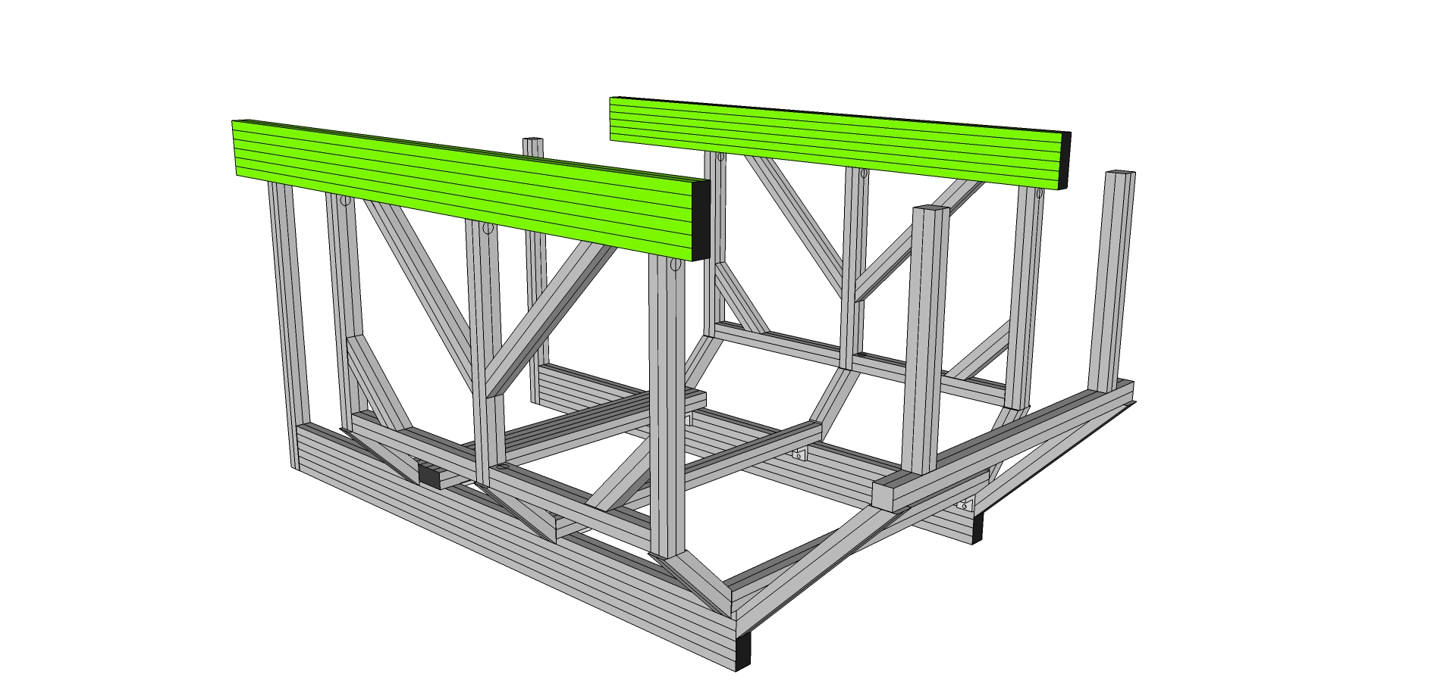

Do not tighten yet.

Step #4 Loosen pre-assembled Socket Head Cap Screw (SHCS) and remove Econ T-nut on four 12” 45 degree supports (9230323). (Parts that were set aside earlier, two have access holes drilled 2” from end (REAR) and two have holes 5” from end. (FRONT))

Step #5 With the Econ T-nuts removed from 9230323, slide the preloaded bolt head on each Rear Verticals (9230310) and Front verticals (9230303) into the lower channel.

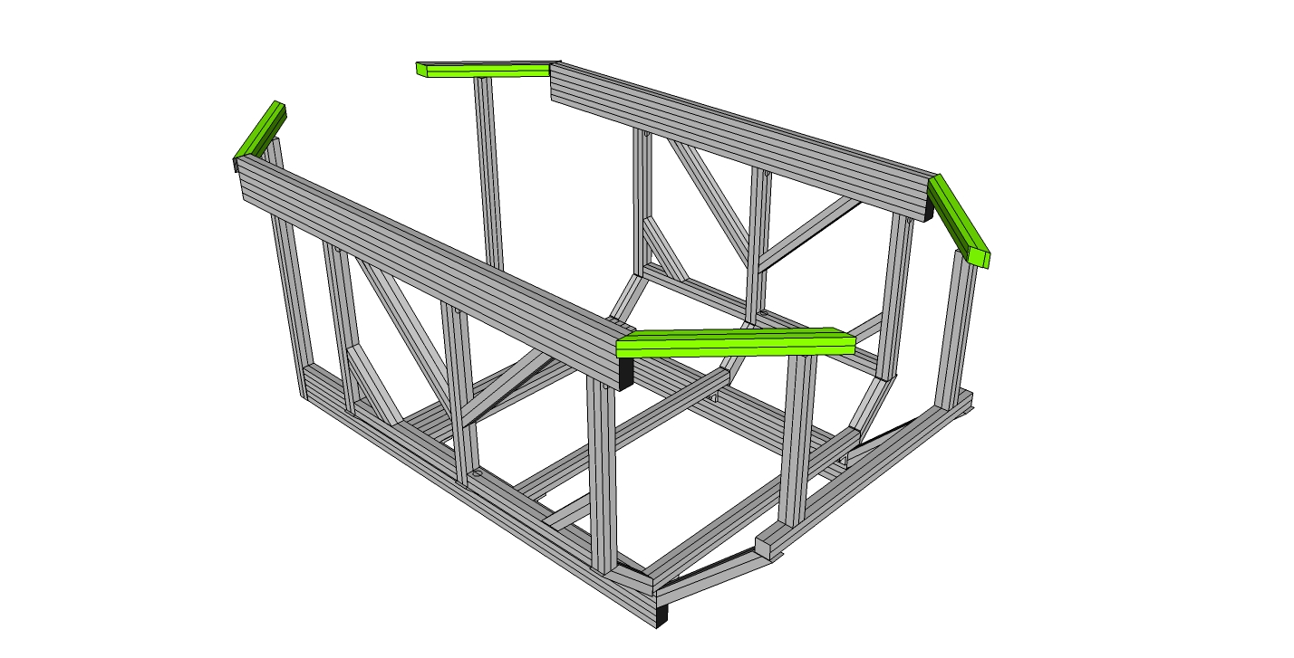

Step #6 Screw the four supports (9230323) into the main upper side (9230318). For the rear two supports (with the access hole 2” from the end), orient the access holes 2” from the inside end and screw the supports into the TOP hole on the end of the main side rail (9230318). ). For the front two supports (with the access hole 5” from the end), orient the access holes 5” from the inside end and screw the supports into the BOTTOM hole on the end of the main side rail (9230318) as shown. Tighten.

Step #46 Bolt the Rear Horizontal Cross Member (9230333) and Front Horizontal Cross Member (Top) (9230325) into place. Keep in mind the orientation of the access holes for the pitch actuator mount in the rear. They should be up and down.

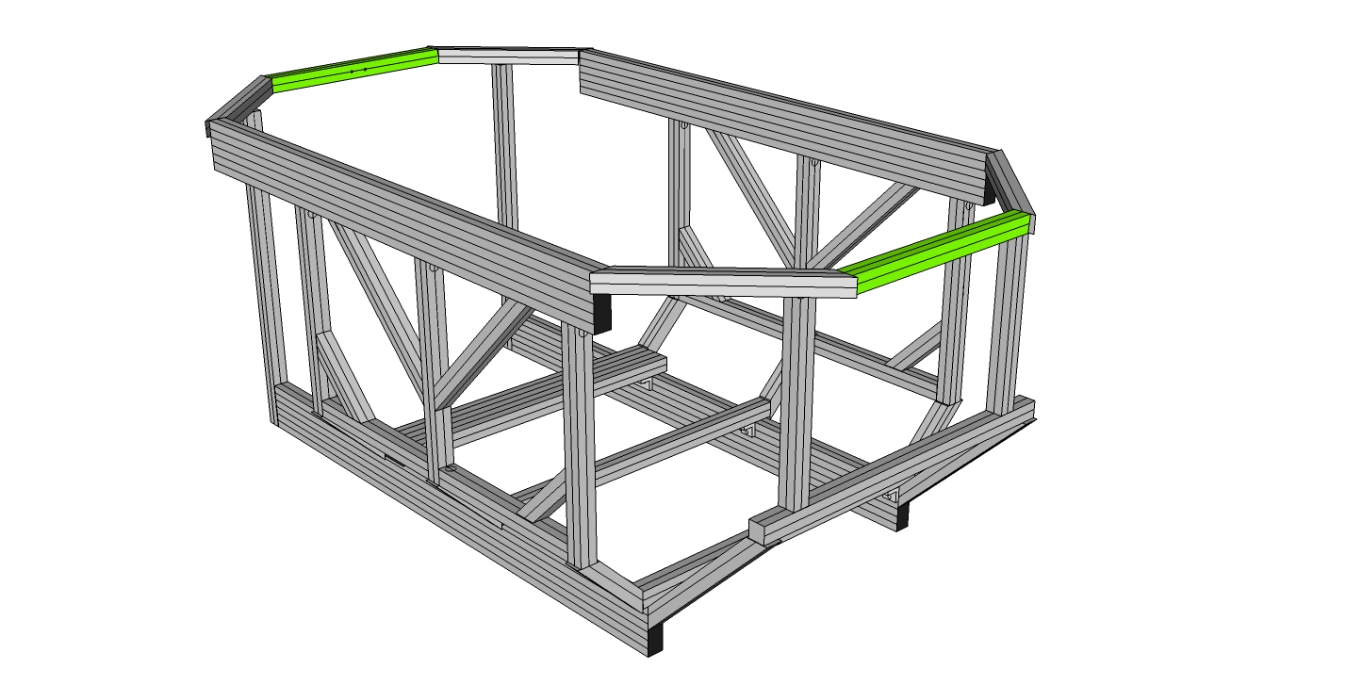

Square and align the mating profiles for the anchor fasteners in the main verticals to the main sides and the Main Upper Sides (9230318). Using a T-handle hex wrench, tighten the screw in a clockwise motion until the profiles are securely affixed. Tighten all. Check all bolts on the cockpit and tighten.

SubAssy Seat Mount

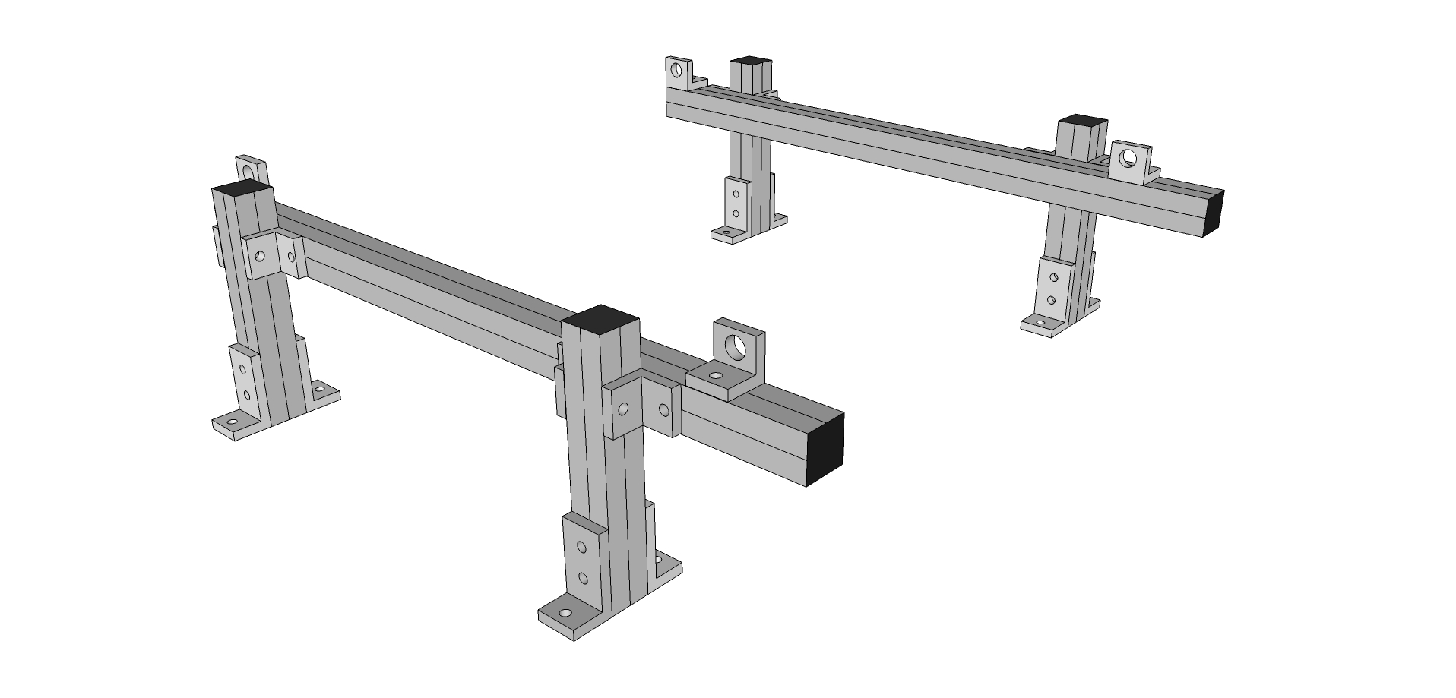

Depending on the type of seat you will be using, you should follow the relevant steps below pertaining to your seat. You may also obtain the seat bracket produced by your seats manufacturer and use instead of this subassy. Measure your seat or find dimensions online before beginning this subassy.

## Normal Configuration vs. Wide Configuration

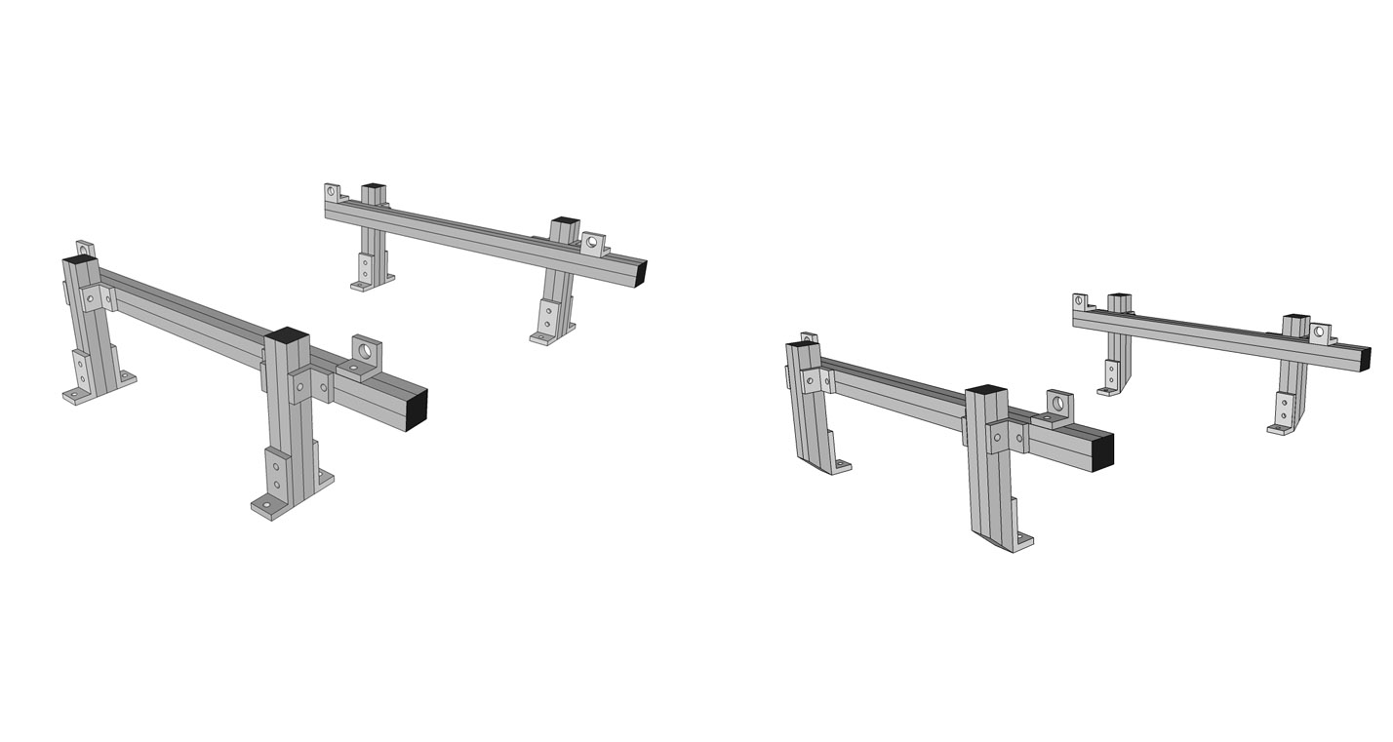

Select one of the configurations, normal or wide.

Step #1 Prep Eight (Normal) or Four (Wide) 3 hole inside corner bracket connectors (9234176) with Econ T-Nuts and Bolts 9233393. Keep the nuts loose to allow sliding into place. **IMPORTANT: only put bolts in the lower (single) hole side as we prepped the cross members already with T-Nuts.**

Step #2 Affix the three hole corner brackets (9234176) on the four seat posts (9230311a for wide or 9230311b for normal) Aligning Econ T-nuts to Slide Two Seat Posts with corner brackets onto Center and Back Lower Cross Members (9230309), each outside edge of bracket flush to each end. To tighten place T-handle hex wrench into SHCS tightening clockwise until secure.

**NOTE: For WIDE configuration, the 3 hole inside corner bracket connectors (9234176) on the outside (four of them) are not needed. This will allow the four posts to be positioned flush with the outside edge of the Center and Back Lower Cross Members (9230309).**

Step #3 Prep eight 2-hole inside corner bracket connectors (9234119) with 16 of the Econ T-Nuts and Bolts 9233393. (Keep the nuts loose to allow sliding into place.)

Step #4 Slide four of the 2-hole brackets (9234119) into the same channel of two Seat Rail (9230312) sides, as shown. (Make 2)

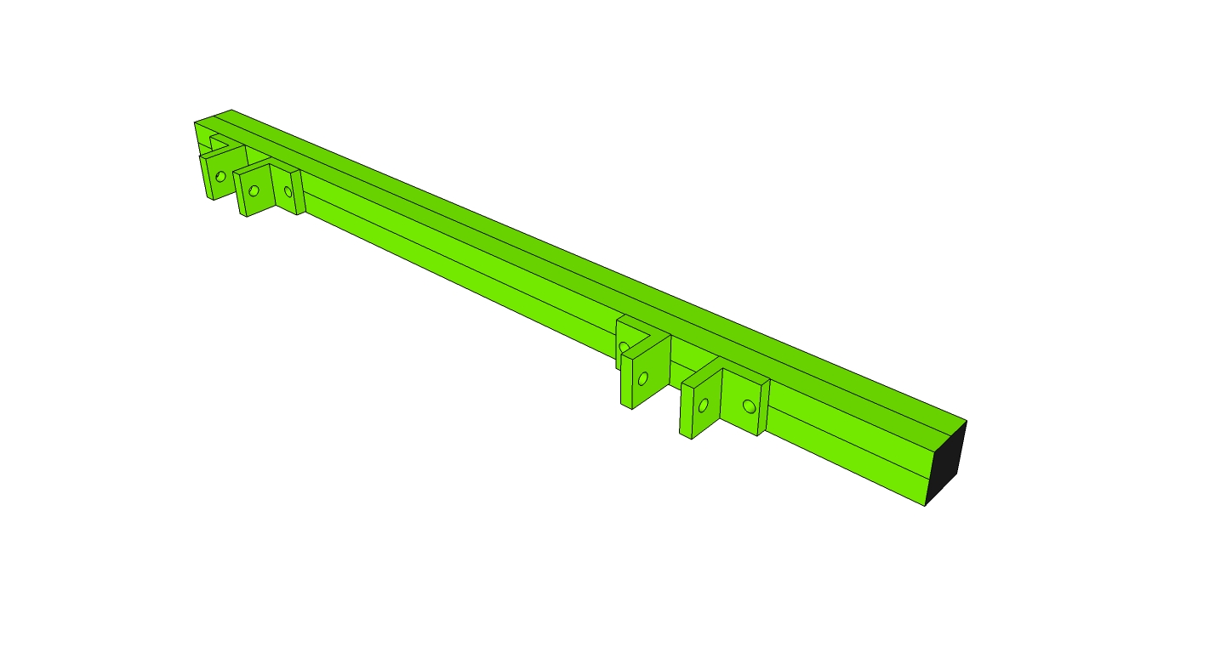

Step #5 Slide seat rails over the seat posts one 2 hole bracket per side of post 2 hole inside corner bracket connectors (9234119) and tighten slightly. Some adjustment will be needed as you integrate your seat.

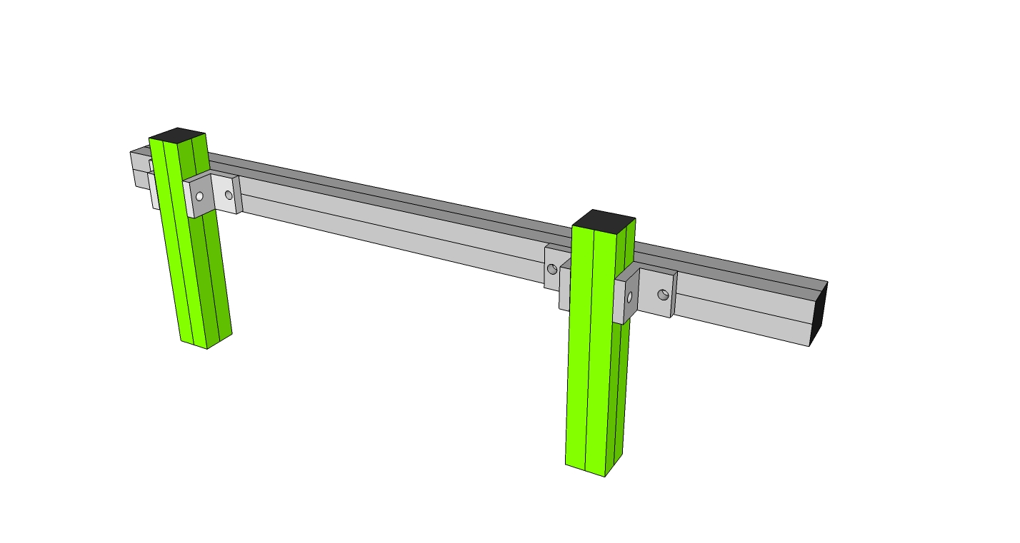

Step #6 Prep the 2 hole standard transition inside corner bracket (9234503) with one T-Nut and Bolt in the ¼ hole. The other hole will be used to bolt into your seat.

Step #7 Slide your transition inside corner brackets (9234503) into place. Both side mount or bottom mount orientations are possible as shown below.

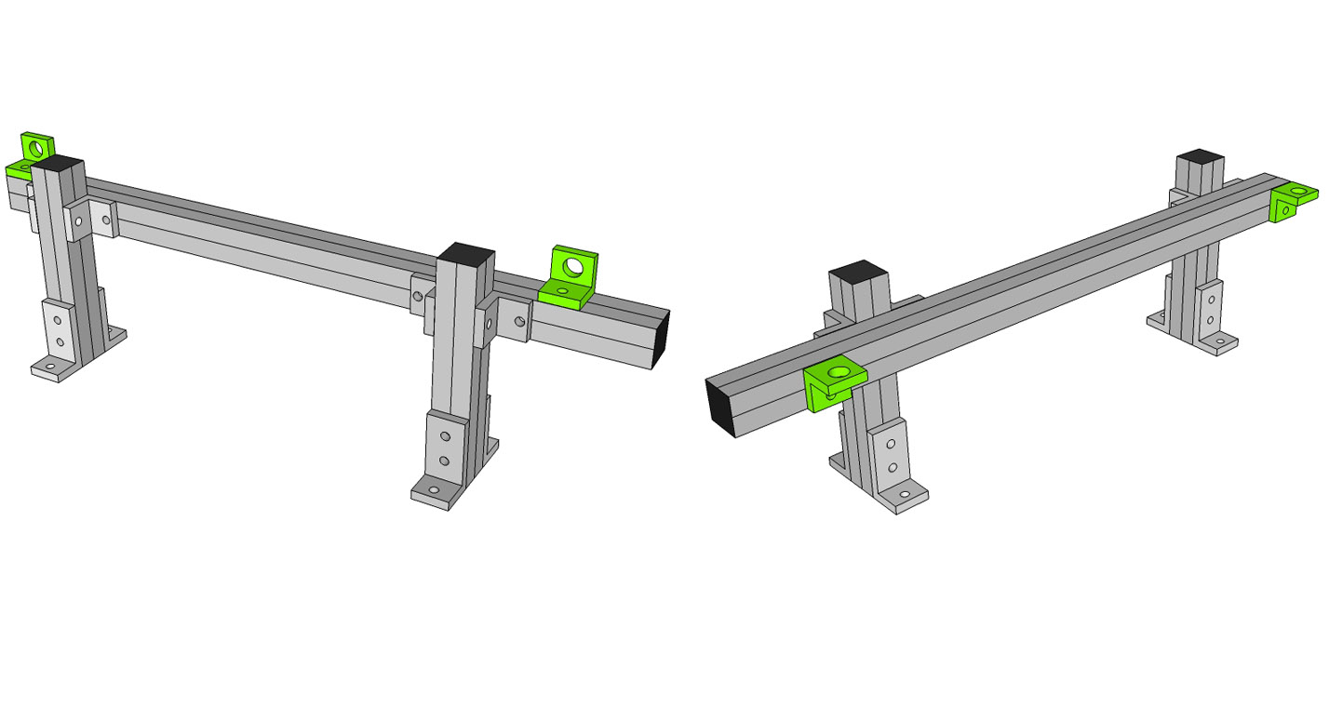

## Integrating the seat mount subassy into the cockpit

*For Wide configuration*

Step #1 Remove T-Nut on the mitre cut end of the four seat posts (9230311a).

Step #2 Place a drop-in T-Nut inside the top channel of the 6” 45 degree supports as shown and attach subassy to the cockpit.

Step #3 Slide the preloaded T-Nut in the inside channel and affix the three hole corner bracket to both the Center and Back Lower Cross Members (9230309) as shown. Tighten the bolts to fix in place.

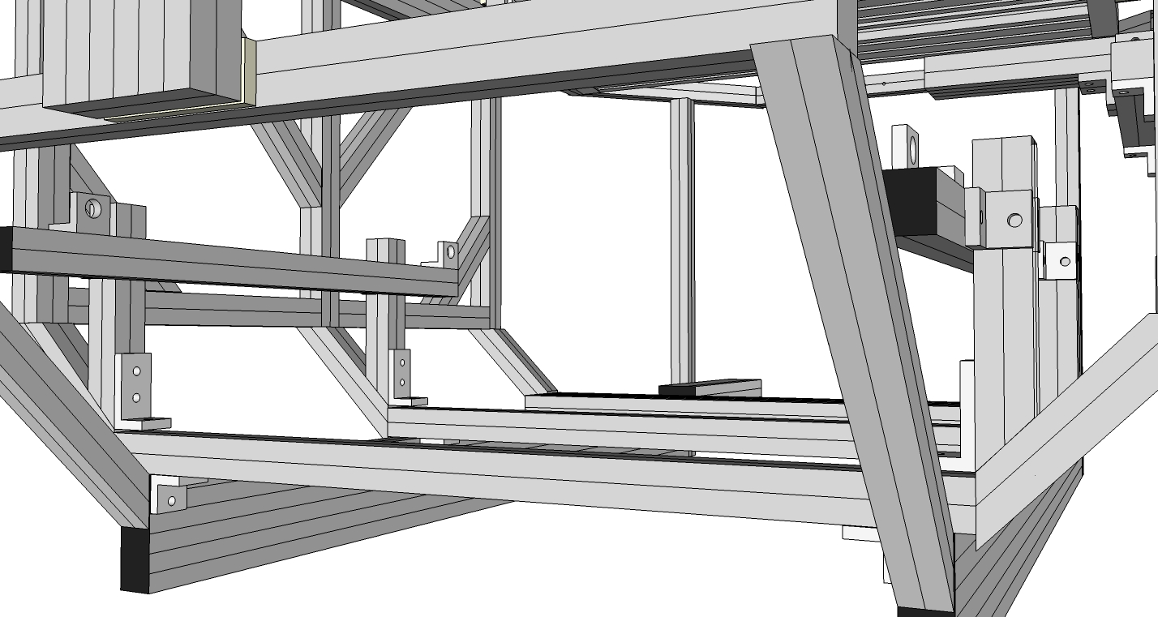

*For Normal configuration*

Step #1 Position the preloaded T-Nuts into place and attach the lower portion of the three hole corner brackets to the chassis as shown. Leave the bolts and T-Nuts loose for seat fitting.

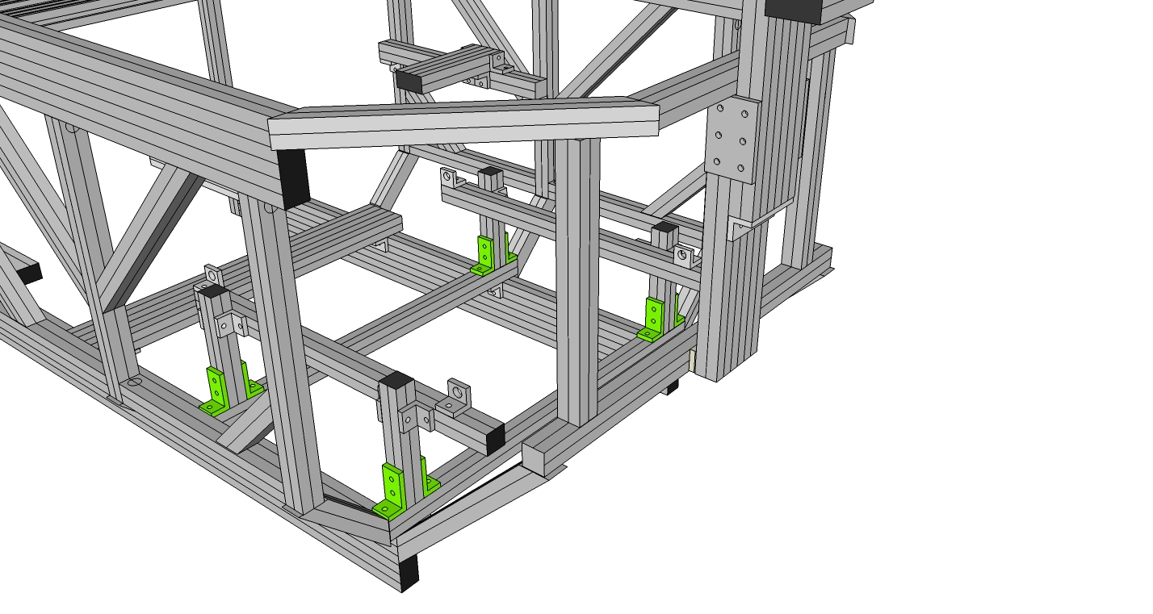

## SubAssy Wheel Shelf

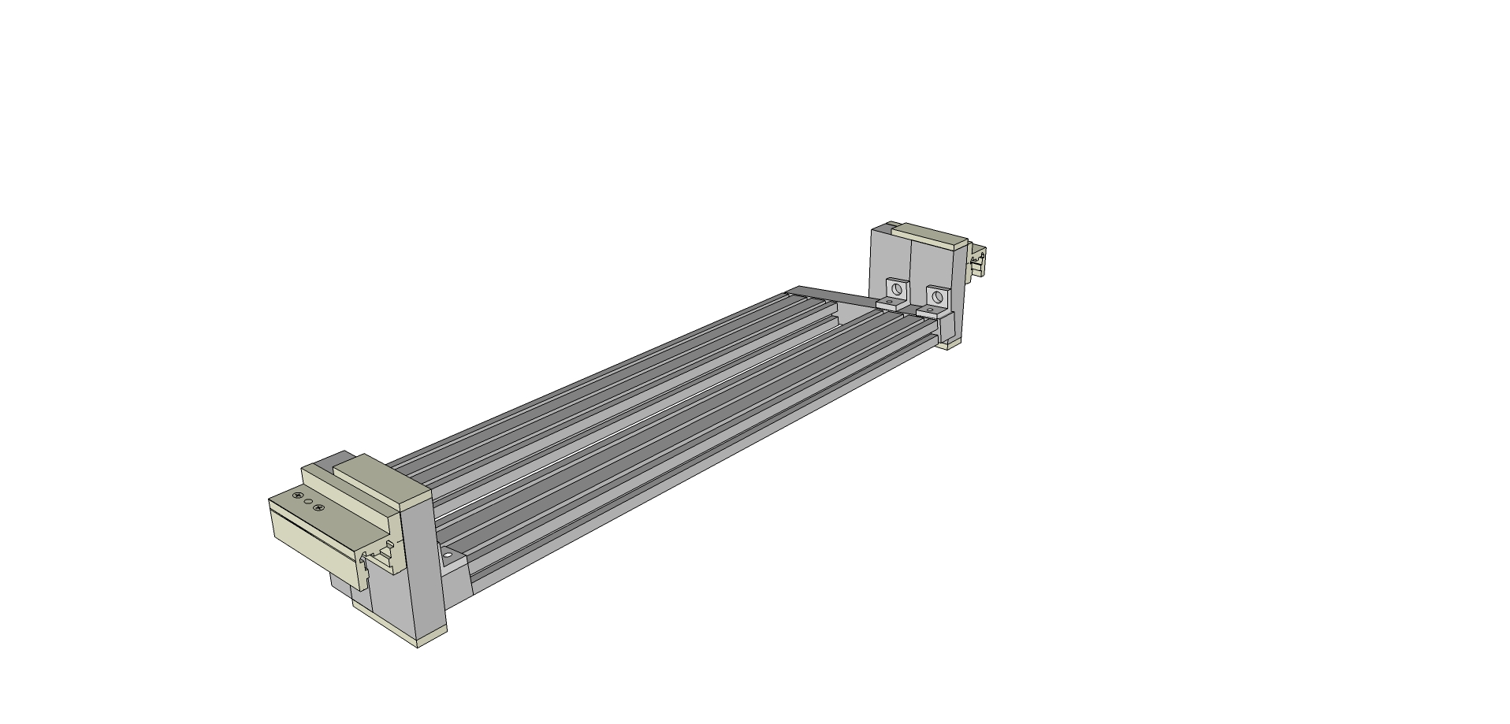

Step #1 Prep four 2 hole inside corner brackets with T-Nuts and Bolts.

Step #2 Slide the four 2 hole inside corner brackets into the Steering Wheel Studs (9230336), two on the right and two on the left channel. Tighten slightly. Set aside

Step #3 Prep both Steering Wheel Bar (9230334 x 2) ends with end fasteners, eight in total.

Step #4 Slide the Steering Wheel Side Rails (9230335) into place over the end fasteners of the Steering Wheel Bars (9230334) as shown. Tighten through access holes in the side rails.

Step #5 Repeat on the other side, attaching the other side rail to the other end of the Steering Wheel Bars.

Step #6 Now take the Prepped Wheel Studs and slide into place as shown. Tighten slightly. Repeat on the other side.

Step #7 Preload the linear slide bearings (9236416) with four 5/8” Bolts and T-nuts (9233822) along the top row of mounting holes.

Step #8 Affix the L-Handle brake (9236850) to the top hole of each of the linear slide bearings (9236416)

Step #9 Slide the linear slide bearings (9236416) into place on the outside of the pre-assembled Steering Wheel Studs (9230336) as shown and tighten.

Step #10 Take two tree hole mounting plates and affix one on the top and one of the bottom of the combined Studs. (Use 9233305 bolts) Repeat on the other end.

Step #11 Set aside until the monitor mounting stage.

## SubAssy Pedals :: Top Hinge or Bottom Hinge

***Top Hinge***

Step #1 Prep six 3-hole inside corner brackets (9234176) with 18 the Econ T-Nuts and Bolts 9233393.

Step #2 Slide onto the Top Hinge Rails (9230909) as shown. (Make 2)

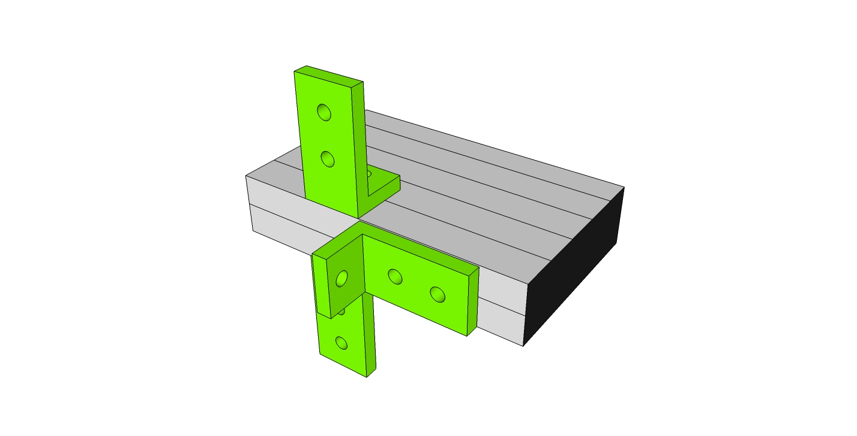

Step #3 Slide onto front verticals (9230303). Once pedals are mounted, adjust to desired height. Use drop-in t-nuts for the front channel bolts.

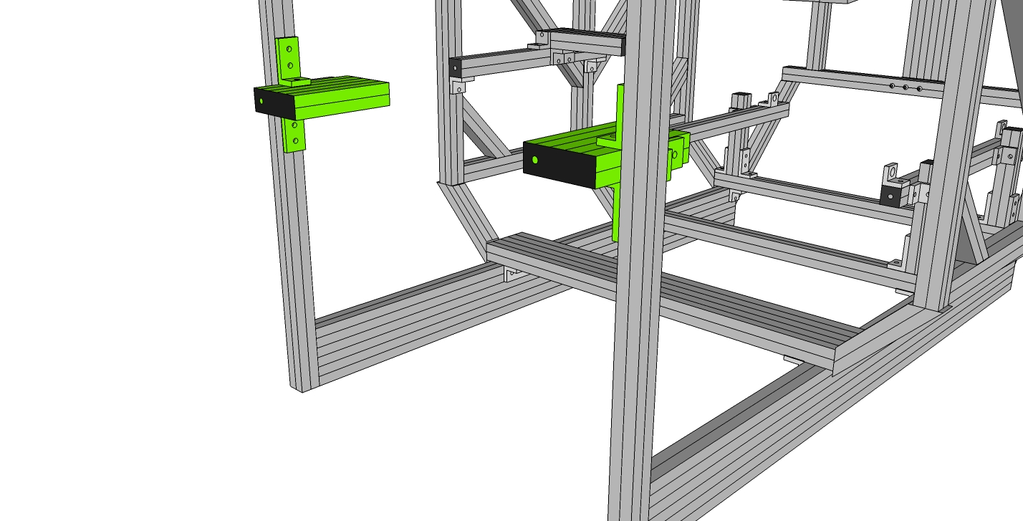

***NOTE:*** For taller users, the 3-hole inside corner brackets (9234176) mounted on the single, horizontal sides of the subassy can be switched to the outside slot, allowing for longer pedal adjustability.

## 

## Bottom Hinge

Step #1 Prep Two Pedal Support Front/Back Rails (9230906) with 4 End Fastener Assemblies (9233381) and Prep Two Pedal Support Center Rails (9230907) with 4 End Fastener Assemblies (9233381) Prep two Center Rails (9230907) with end fasteners (9233381) on each end.

Step #2 With the End Fastener (9233381) slightly loosened, slide the Center Rails (9230907) onto Front/Back Rails (9230906). It is important to orient Center Rails with access holes oriented the same way. When aligned, the access hole on the mating profile. (Approximately 4 1/2” from each end which should align with the BHSCS.) Tighten the connections, place a T-handle hex wrench into access hole until the wrench head inserts into the BHSCS.

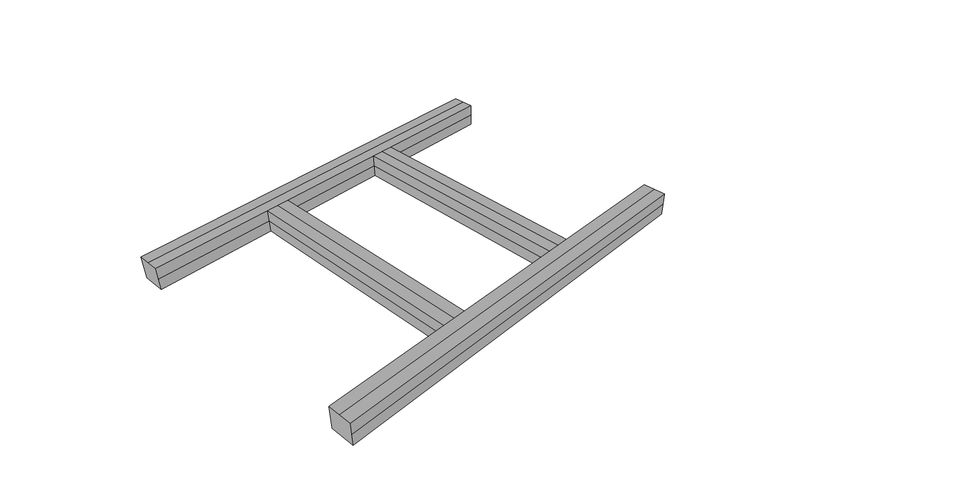

Step #3 Prep Front/Back Rails (9230906) with end fasteners on each side.

Step #4 Slide Pedal Side Supports (9230908) on each side of Front/Back Rail (9230906). It is important to orient access holes approximately 4 1/2” from end to the tapped ends. To tighten the connection, place a T-handle hex wrench into access hole until the wrench head inserts into the BHSCS. Tighten all four clockwise until secure. IMPORTANT, make sure the tapped hole end of the side supports (9230906) are both on one end.

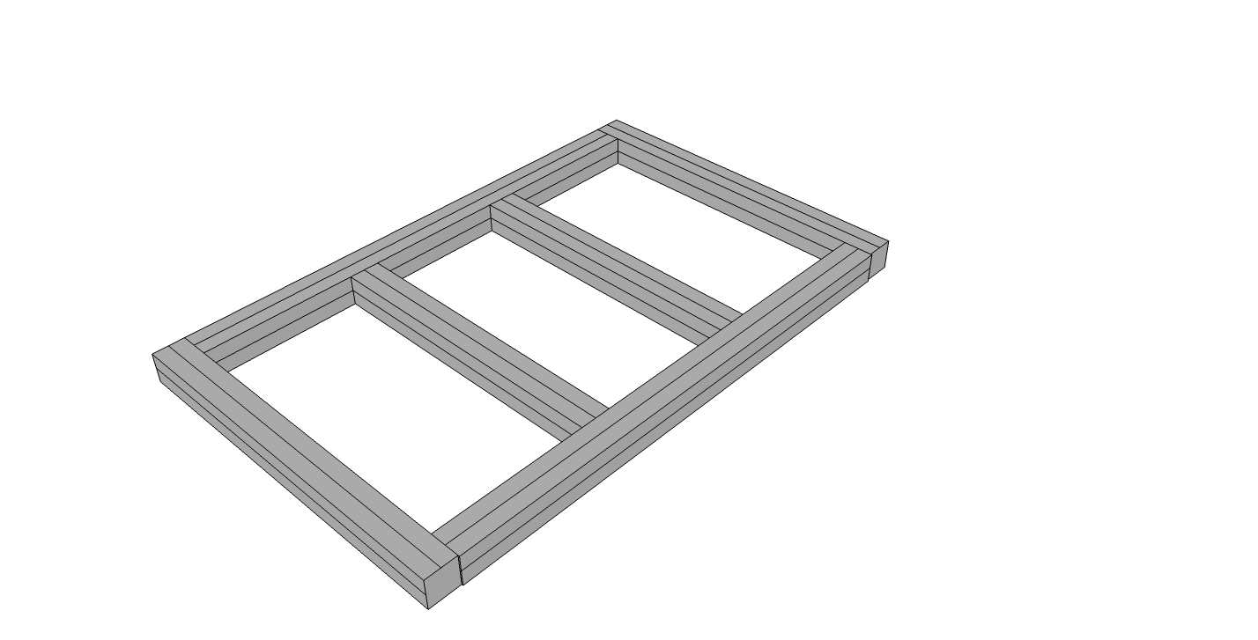

## 

## Integrating the pedal mount subassy into cockpit

Step #1 Determine your preferred pedal location. You can mount the supporting 2 hole brackets on the top or any of the side channels of the cockpits bottom rails. Prep Two 2 hole inside corner bracket connectors (9234119) with 2 of the Econ T-Nuts and Bolts 9233393. (One nut/bolt in each, leaving the other hole open.) Keep the nuts loose to allow sliding into place. For the top channels, use drop-in T-Nuts. For the bottom two channels, you can slide T-Nuts in from the back of the cockpit.

Step #2 Slide the two brackets from the previous step onto the desired channel of each inside Bottom Rail (9230301). Slide from the back to the front if needed.

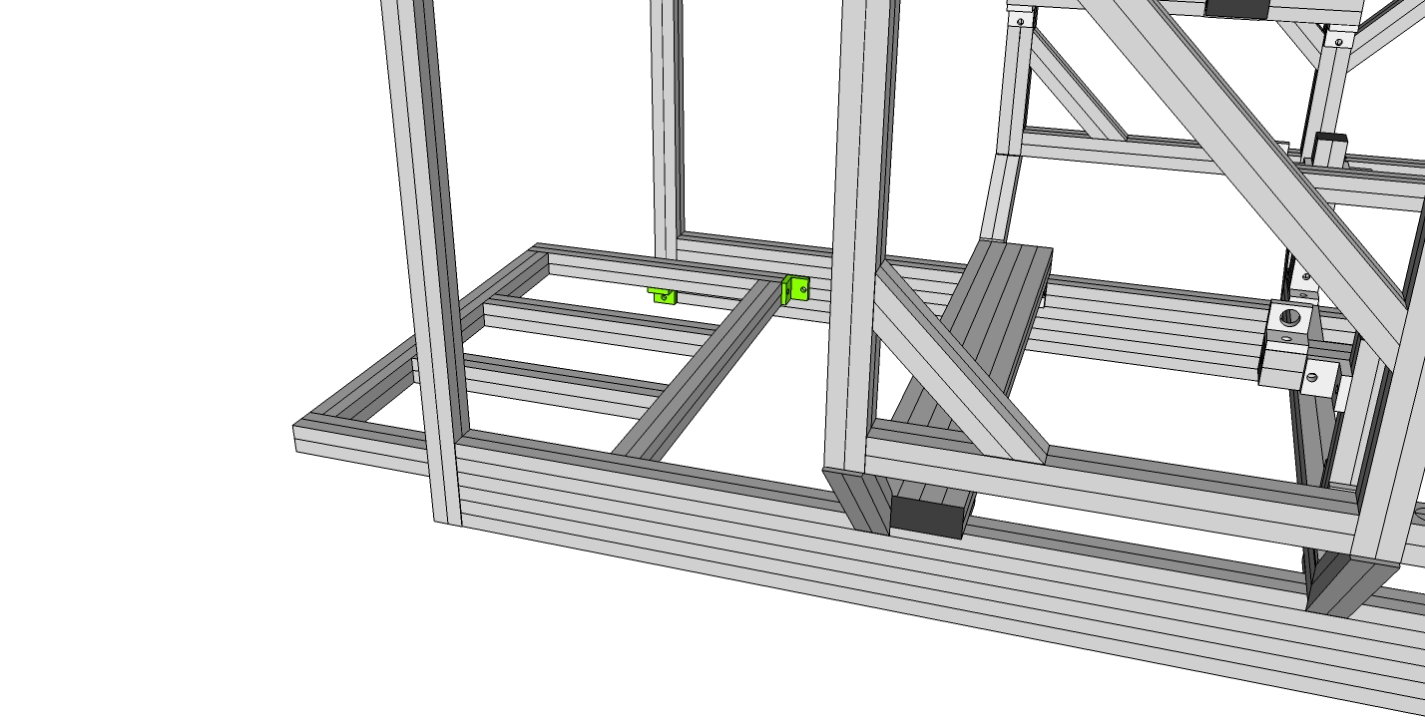

Step #3 Attach Pedal Side Support Rails to connectors (9234119) by inserting two bolts (9233393) through the two-hole bracket (9234119) and into pre tapped hole in the end of Pedal Side Supports (9230308).

Step #4 Prep Two 2 hole inside corner bracket connectors (9234119) with 4 of the Econ T-Nuts and Bolts 9233393. (One nut/bolt in each hole.) Keep the nuts loose to allow sliding into place.

Step #5 Slide 2 hole inside corner bracket connectors (9234119) into the bottom of the Pedal Side Supports (9230308) then into the bottom of the Front Vertical Supports (9230303) as shown. To tighten the 9234119 place T-handle hex wrench into SHCS tightening clockwise until secure forming a slight angle of the pedal support. You should wait to fully tighten until you can test the pedal position once the seat is installed. Position will also depend on the type of pedals you will use. If using top-hinge pedals, this assembly can act as a heel plate as shown below.

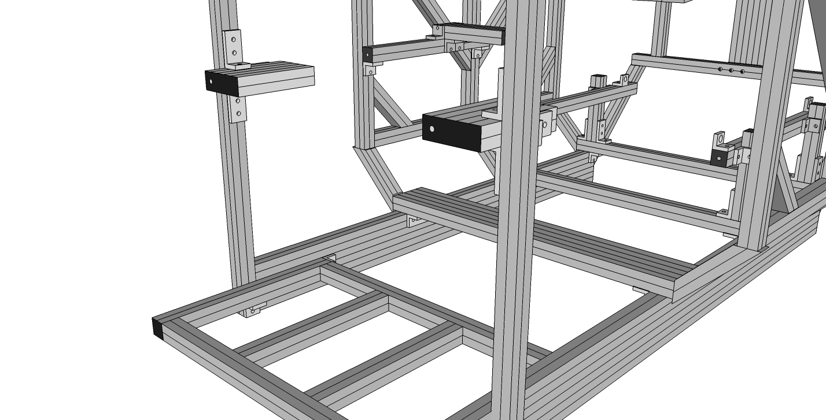

## SubAssy Shifter Mount

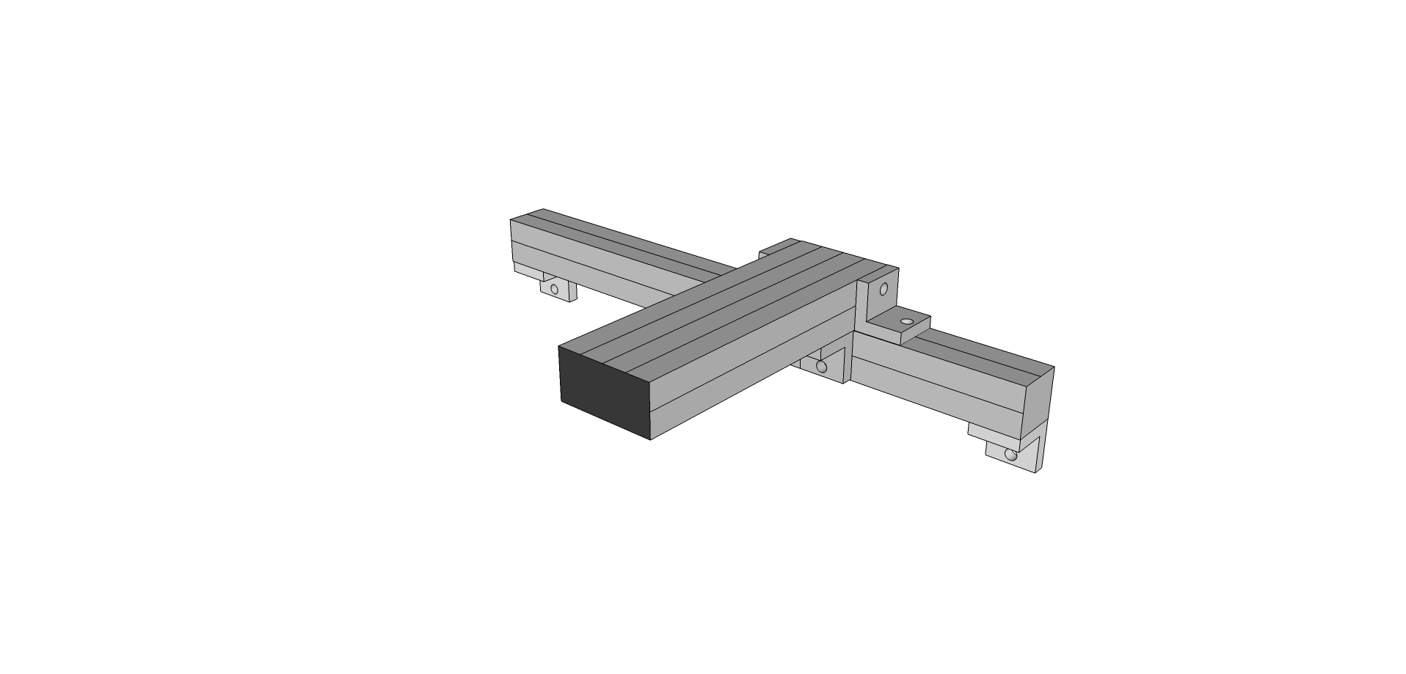

Step #1 Prep six 2-hole brackets (9234119) with Econ T-Nuts and Bolts 9233393

Step #2 Slide onto bottom channel of the Shifter Rail (9230315)

Step #3 Slide Shifter Rail (9230315) with Fasteners aligned over the left or right front Two Main Verticals. (Depending on whether your shifter will be left or right mounted.) Tighten. Use Drop-in T-Nuts in the cockpit verticals as needed.

Step #4 Slide connectors (9234119) onto Shifter Rail Bar (9230316). Tighten. Then Slide Shifter Rail Bar (9230316) with Econ T-Nuts and Bolts 9233393 aligned onto Slide Shifter Rail (9230315). Adjust to desired position.

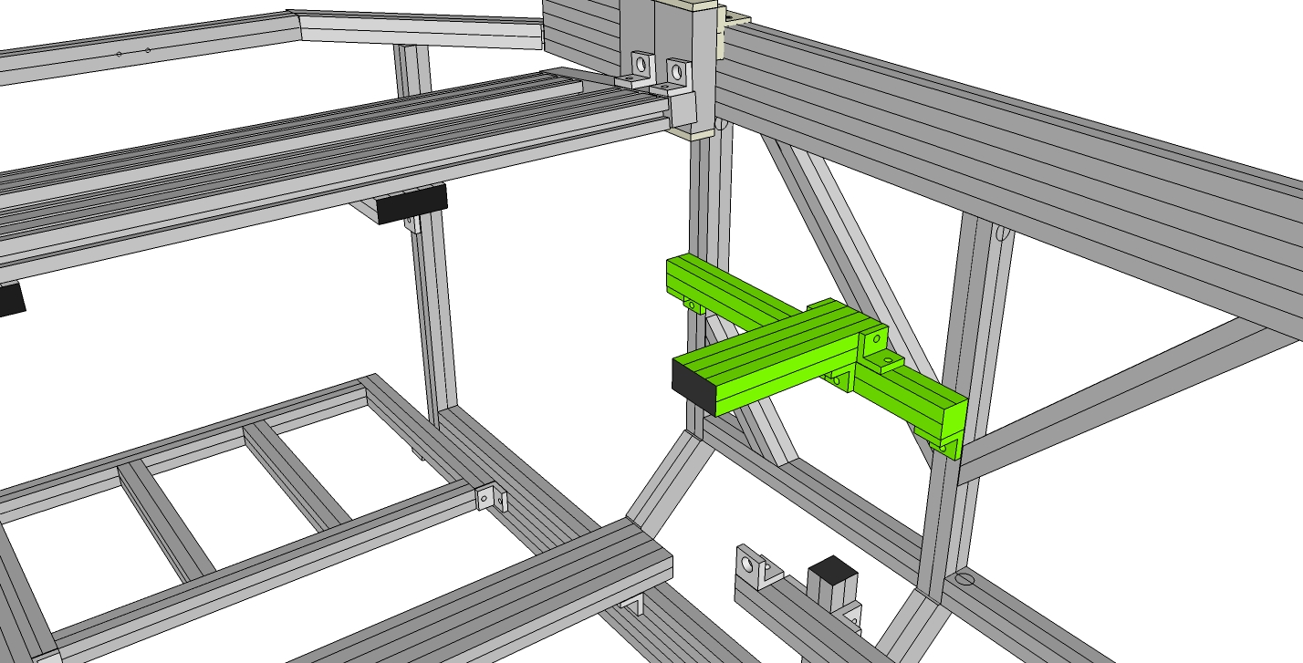

## SubAssy Monitor(s) Mount

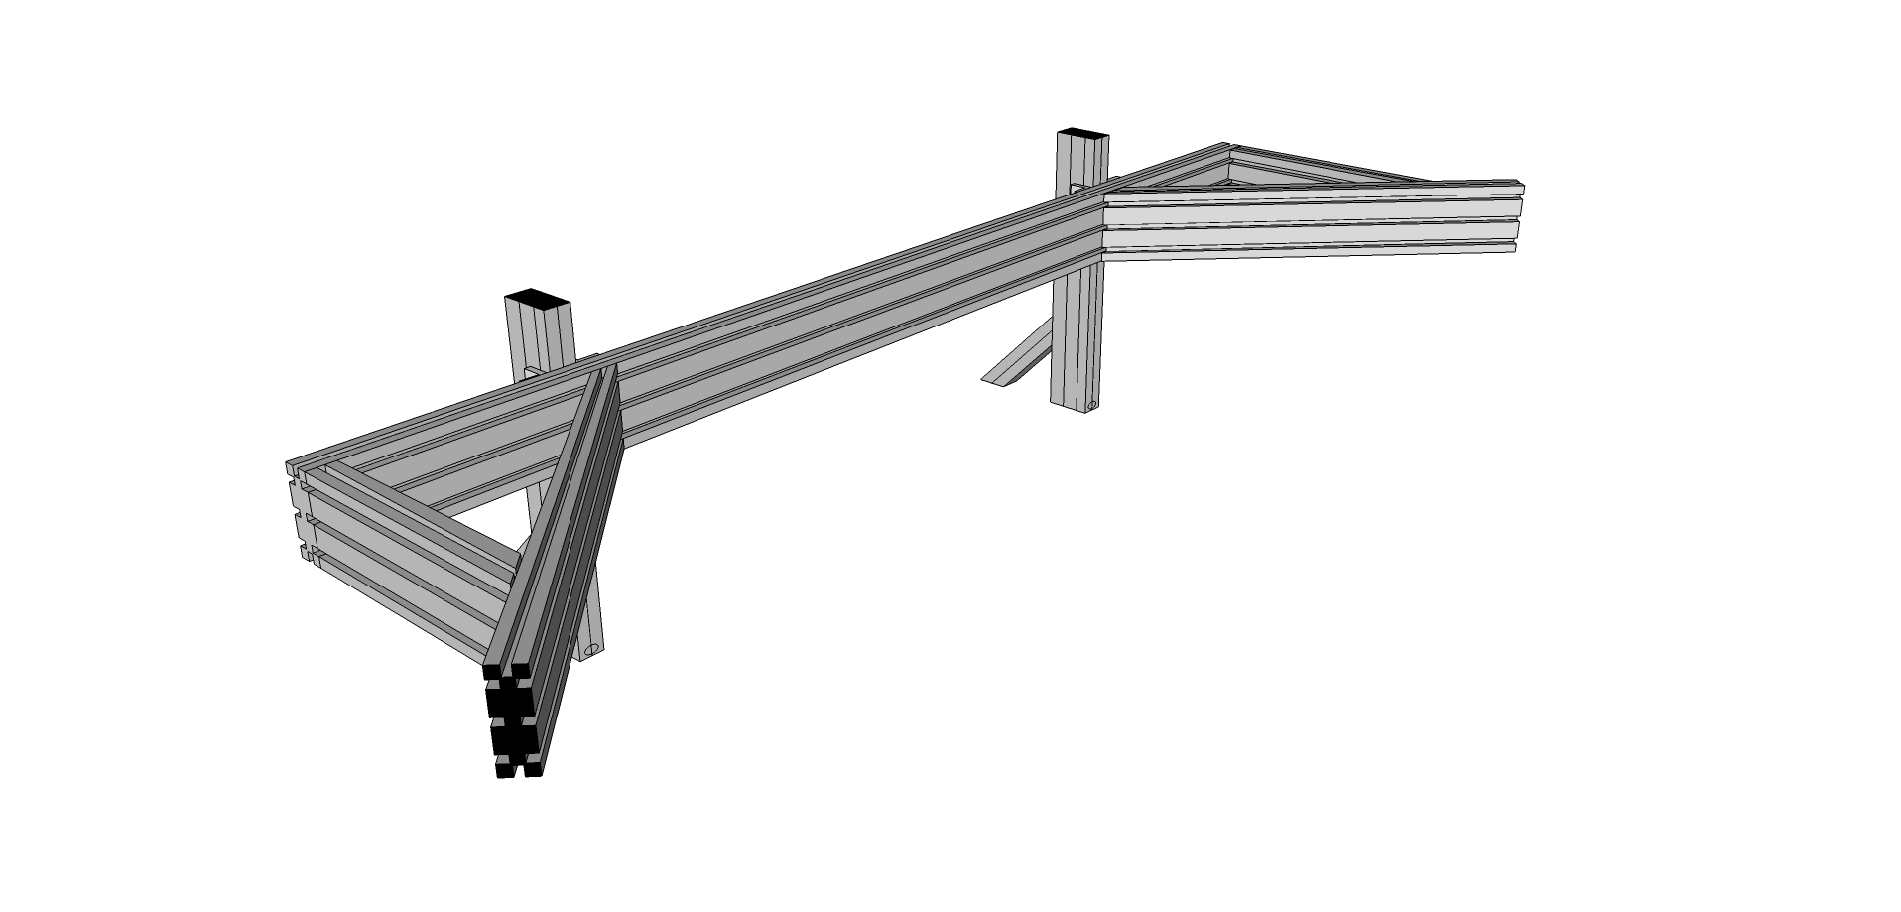

Step #1 Prep four 6-hole corner brackets (9234015) with T-Nuts and bolts (9233393) leaving the T-Nuts loose for inserting and sliding in the T-Slot.

Step #2 Slide two of the four 6-Hole corner brackets onto the monitor vertical posts (9230340) as shown below. Tighten slightly and repeat on the second post.

Step #3 Loosen the Econ T-nut (but leaving the bolt and washer) on one six 6” 45 degree supports (9232565) and attach to the Post as shown. Repeat on the second post.

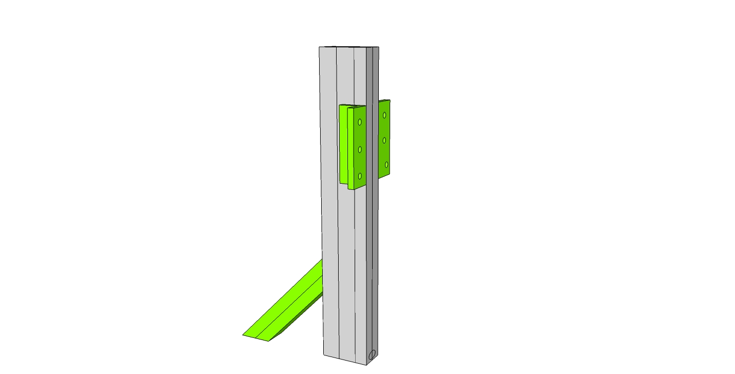

Step #4 Slide the main cross member into place as shown and slightly tighten all twelve T-Nuts in the four 6-hole corner brackets on the backside. The posts should have a distance of about 27.5” between them. This distance can be adjusted when affixing this subassy to the main cockpit assembly.

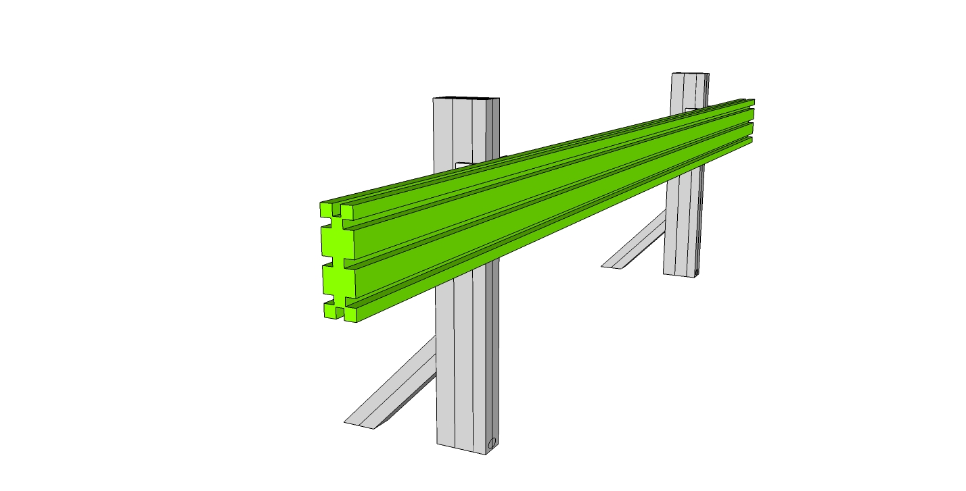

Step #5 Prep both 9230337 side supports with end fasteners, the attach the mitre cut end to the longer diagonal support (9230338) as shown below. Position the left side faces in the drawing below in a same plane manner. Loosen the T-Nuts in the longer support.

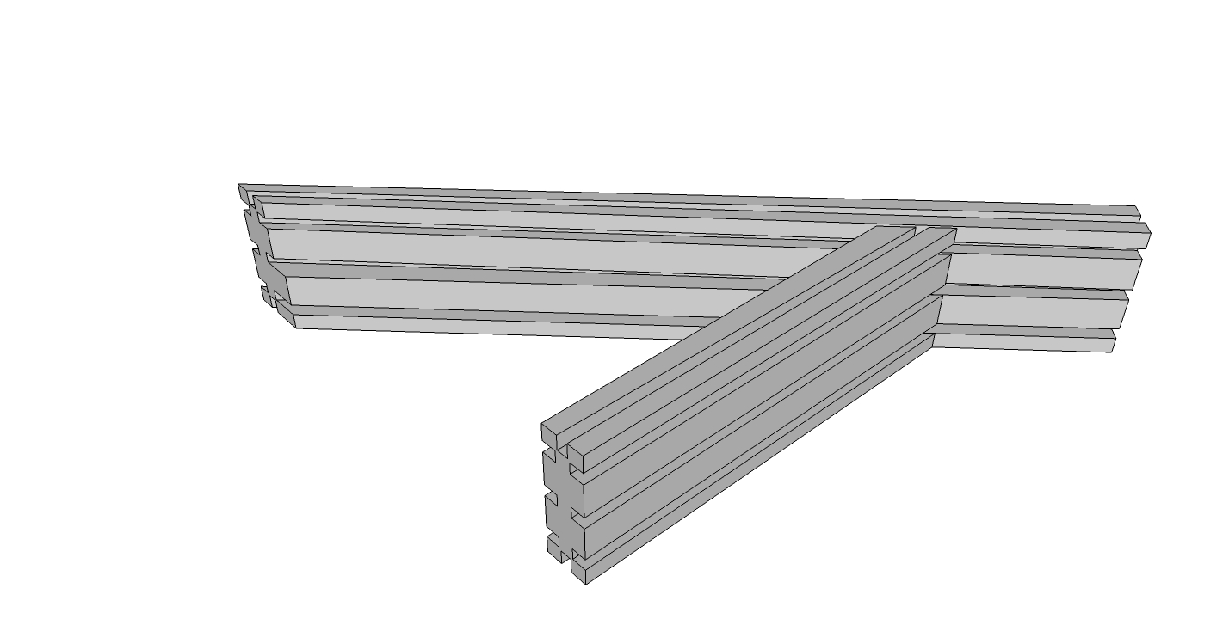

Step #6 Attach the subassy of Step #5 to the rest of the monitor mount subassembly by sliding the t-nuts in the longer diagonal support into the front facing channels of the rest of the monitor mount subassembly. Align the three access holes on the end of the main cross member to the end fasteners in the side supports. Tighten the three end fasteners and the three t-nuts. Repeat on the other side.

## Integrating into the rest of the cockpit assembly

Step #1 Prep four anchor fasteners (9233395) for the bottom of each monitor vertical post (9230340). Anchor Fasteners are composed of three parts: The Head Cap, Screw, the Anchor Cam, and the T-nut. Your Anchor Fasteners should ship Pre-assembled. If assembly is needed, refer to the photo (Note: offset tapped hole in T-nut)

Step #2 Load the assembled anchor fastener into the counterbore holes of monitor vertical posts (9230340), two in each. Be sure to position the T-nut with the offset hole oriented toward the top of the fastener.

Step #3 Remove the front 45 degree supports and the front cross member.

Step #4 Before mounting the monitor support, retrieve the wheel mount sub assy and slide the linear bearings onto the top of the Upper Sides (9230318) as shown.

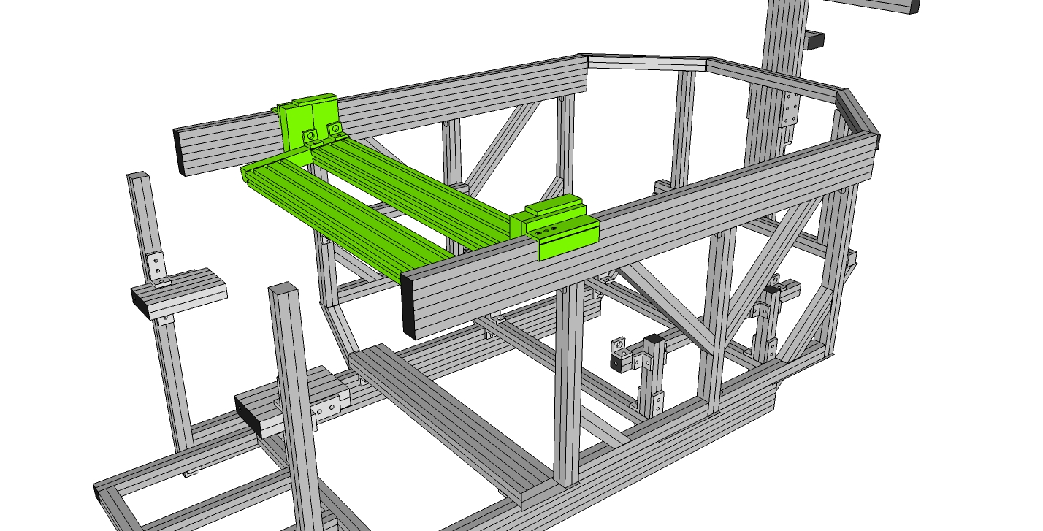

Step #5 While holding the Anchor Fastener in the counterbore hole, slide the monitor subassy into the top channel of the Upper Side (9230318), then feed in the T-Nut from the 6” 45-degree support. Tighten all bolts once in place.

Step #6 Replace the front 45 degree supports and the front cross member.

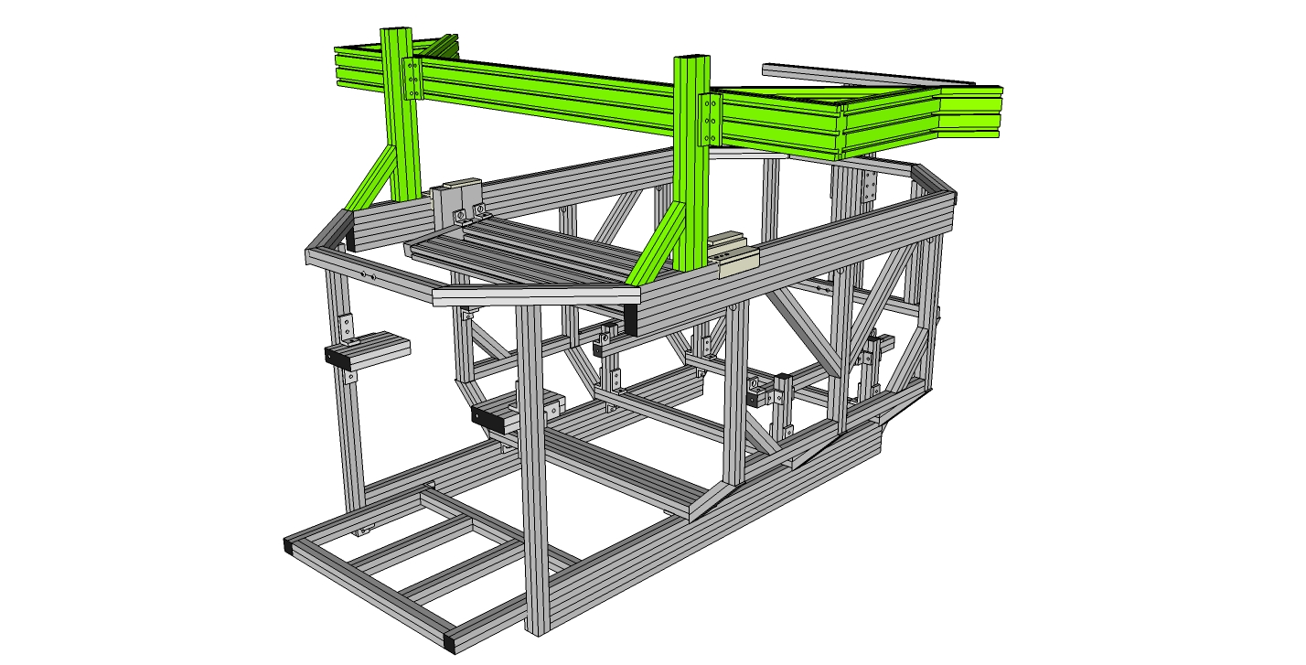

# 

# Final Assembly

The final steps of assembly can be done in different orders. If you have plenty of “lifting help”, you may choose to mount everything in the cockpit, (seat, monitor, controls) before assembling the cockpit, roll frame, and base cradle. Keep in mind that everything added to the cockpit while it sits on the floor adds more weight for when you will need to lift it into place on the rest of sim.

## Finishing the Cockpit

### Mounting the Seat

For side mount seats, (RECARO Pole Position, Corbeau FX-1 Wide) use the four 2-hole transition inside corner brackets (9234503) along with four 9233393 Bolts/T-Nuts.

Step #1 put seat in place and using the 4 bolts supplied for your seat, bolt in place, through the 9234503 holes and into seat.

Positioning the seat: It is of vital importance that the seat NOT contact any part of the cockpit chassis structure, other than the seat mounting structure. Do not rest the back of the seat on the rear top cross member behind the seat. Also, using a seat slider under the seat is not recommended.

### Mounting the Monitors

Step #1 Using T-Nuts and 3321 bolts, prep the monitor mounting plate holes and then slide the T-Nuts into the monitor assembly. Use Drop-in t-nuts as needed.

Step #2 Tighten the bolts once the plate(s) is properly positioned.

Step #3 Place monitor(s) on the mounting plate and affix using supplied hardware.

### Mounting the Wheel, Shifter and Pedals

Step #1 using the built in clamps for the G25/G27 shifter, mount the shifter to the shifter mount in the cockpit.

Step #2 using the built in clamps for the G25/G27 wheel, mount the wheel to the center of the wheel bar. Make sure to tighten the clamps as tight as possible. Use a set of rubber tipped pliers if needed. (you will need to run wiring from the pedals and the shifter, so it may be appropriate to wait until the wiring is completed before tightening down fully.

Step #3 If you are using the Logitech G25/G27 pedals, use the two supplied M6 x 40mm bolts (9236540). Put the bolts up through the access holes in the bottom of the center rails in the pedal “shelf”, and tighten. The access holes should line up with the center line hardened mounting holes in the bottom of the G25/G27 pedal set.

### Mounting the Cannon GT Pedals

Step #1 You will be placing the pedals inside the 5” Cannon Pedal Framing installed on Step #24 of the cockpit assembly. (You may need to adjust the width of the black side framing on the pedal set to fit snug in between these two frames. To do so, simply loosen the collar locks holding the frames in place on the two cross rods on the assembly and slide into place. The outside dimension for the Cannon framing should be 13” to fit snug inside the 5” Cannon Pedal framing mountings.)

Step #1a Prep the pedal set with four 1.25 bolts and T-Nuts (9233307). Do not fully tighten the four T-Nuts as they will slide into the inside channel of the 5” Cannon Pedal Framing.

Step #1b Place the pedal set into place and tighten the four T-Nuts.

Step #1c Adjust the pedals into the appropriate position. You may choose to use the pedal shelf for the G25/G27 pedals as a heel plate.

**Mounting the Cannon F1 Pedals**